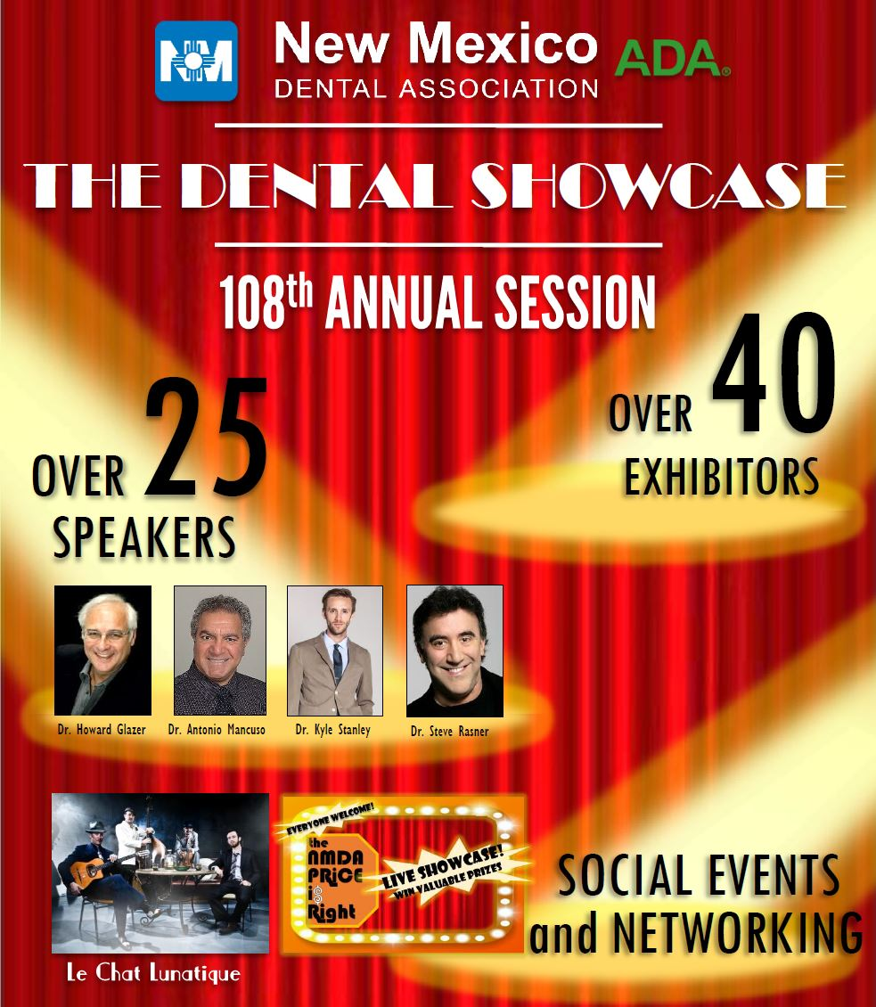

Speaker Bios

|  |  |  |
| --- | --- | --- |
| Prefix | Spkr FN | Spkr LN |
| Ms. | Cathryn | Albrecht |
| Dr. | Christopher | Baer |
| Ms. | Jill | Baskin |
| Dr. | Lionel | Candelaria |
| Ms. | Renee | Cina-Acosta |
| Dr. | John | Cornali |
| Ms. | Stephanie | Dominguez |
| Mr. | Andrew | Eberhardt |
| Mr. | Gary | Fichtner |
| Mr. | Jeffrey | Fraum |
| Dr. | Howard | Glazer |
| Mr. | Joseph | Griego |
| Dr. | Jane | Grover |
| Ms. | Bernadette | Jojola |
| Dr. | Daniel | Klemmedsen |
| Dr. | Antonio | Mancuso |
| Mr. | Michael | McDade |
| Dr. | Drew | McDonald |
| Ms. | Jane | McGinley |
| Ms. | Kim | Miller |
| Dr. | Chris | Morgan |
| Mr. | Michael | Moxey |
| Dr. | Linda | Nichols |
| Dr. | Jonathan | Parker |
| Dr. | Howard | Pollick |
| Dr. | Dan | Poticny |
| Dr. | Steve | Rasner |
| Dr. | Gary | Roberts |
| Dr. | Thomas | Schripsema |
| Dr. | Roy | Shelburne |
| Dr. | Kyle | Stanley |
| Mr. | Tim | Twigg |
| Dr. | Joe | Valles |
| Dr. | Stephen | Wagner |
| Dr. | Byron | Wall |
| Ms. | Andrea | Wiseman |
| Dr. | Ron | Wang |

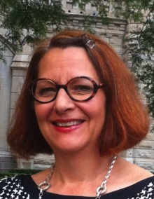**~ Cathryn Albrecht – 108th Annual Session, The Dental Showcase– Speaker  
Speaker Bio:** Cathy Albrecht earned her law degree from Loyola University of Chicago School of Law in 1991, where she graduated cum laude. She holds a bachelor’s degree in Communication Arts from the University of Wisconsin-Madison. Cathy joined the ADA in 2009 after 18 years in private practice, primarily in the area of employment law. As Senior Associate General Counsel, Cathy’s responsibilities include working on various litigation and legal advocacy matters, assisting with human resources matters, addressing insurance coverage issues, and assisting the Director of the Council on Ethics, Bylaws and Judicial Affairs in handling that Council’s matters and responsibilities. Cathy also serves as a legal liaison to the Joint Commission on National Dental Examinations, the Commission on Dental Accreditation, the Council on ADA Sessions, and the Committee on International Program Development. In addition, Cathy is a member of the Association’s Risk Management Team.

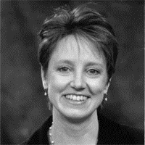**~ Jill H. Baskin – 108th Annual Session, The Dental Showcase– Speaker  
Speaker Bio:** Jill Baskin, DDS graduated from the University of Illinois Dental School and completed a general practice residency at the University of Illinois Hospitals. She currently practices general dentistry in a suburb of Chicago. Dr. Baskin taught in the Periodontics Department of the University of Illinois Dental School for 18 years and has also worked as a dental consultant for Delta Dental of Illinois.   
  
She has been a presenter of CNA’s Dental Professional Liability Risk Management Seminars since October 1988 and has been an active contributor of course content. In addition, Dr. Baskin provides dental expertise to CNA dental malpractice claim specialists.

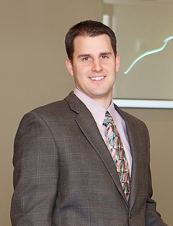**~ Christopher Baer – 108th Annual Session, The Dental Showcase– Speaker   
Speaker Bio**: Dr. Baer maintains a full time clinical practice in Aurora, Colorado where he utilizes digital workflows to provide state of the art dental treatment.  He has been utilizing digital scanning technology in his practice for over 10 years and has published dental articles relating to new dental techniques, dental materials, and digital dental technologies.  He works with several companies to help them in the develop dental products or improve existing ones.  His clinical photography is not only used in his published work, but also by dental manufacturers for their advertisements, product literature and technique guides.  He is a graduate of the Kois Center Program in Seattle, WA and received his dental degree from OHSU in Portland, Oregon.

[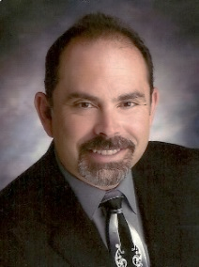](http://www.omsanewmexico.com/files/2011/08/Lionel-Candelaria-pic.jpg)**~ Lionel Candelaria – 108th Annual Session, The Dental Showcase– Speaker  
Speaker Bio:** Lionel Candelaria is in private group practice with the Oral and Maxillofacial Surgery Associates of New Mexico. He attended the University of Mis­souri at Kansas City, where he received his dental degree in 1985, followed by a one-year General Practice Residency at Balboa Naval Hospital, San Diego, California. After two operational tours with the Navy, was accepted into an Oral and Maxillofacial surgery resi­dency program at the University of Tennessee, Memphis. He retired from the US Navy as a Captain in 2005. He is a Diplomate of the American Board of Oral and Maxillofacial surgery and a Diplomate, American Dental Society of Anesthesia. Current committee appoint­ments: AAOMS Committee on Health Care, Consultant to the Cen­ters for Medicare and Medicaid Services Relative Update Commit­tee, 5th year Board examiner and Item writer for the American Board of Oral and Maxillofacial Surgery, Oral and Maxillofacial Surgery Foundation Ambassador, Committee on governmental affairs Politi­cal Action Network, and Albuquerque District Dental society board member. Dr. Candelaria has published and lectured extensively in specialty of dentistry.

Dr. Candelaria practices the full scope of Oral and Maxillofacial Sur­gery at with a special emphasis on cleft palate and dentofacial defor­mities. He has been on cleft palate teams since 1985 while affiliated with the University Tennessee, Balboa Naval Hospital in San Diego California and in private practice in New Mexico. His practice is cur­rently involved with outreach to care for Native American children in New Mexico. He has been on humanitarian medical-dental missions to remote areas of Ghana and Thailand. He provided hurricane disas­ter relief in Texas Gulf Coast, flood disaster relief in Iowa City, Iowa and multiple habitat for humanity missions to Tectae and Puerto Nuevo, Mexico. He is currently undertaking a pioneering project in New Mexico to establish the first Oral and Maxillofacial Surgery residency program at the University of New Mexico Hospital. The program will actively address the critical access to care in maxillofacial trauma, pathology and reconstruction in New Mexico.

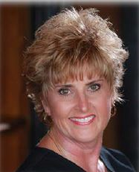**~ Renee Cina Acosta – 108th Annual Session, The Dental Showcase– Speaker   
Speaker Bio:** Renee Cina Acosta has been a Dental Hygienist for 34 years. She is a graduate of the University of Pittsburgh. Renee is also a holistic health coach, trained at The Institute for Integrative Nutrition and is now enrolled at the University of New Mexico to complete her education. Renee is passionate about education in hygiene & nutrition through clinical practice, writing and as a national speaker. She feels that blending more nutritional practices in dentistry can help all dental providers create more awareness and better health practices for their patients and themselves to achieve overall wellness.

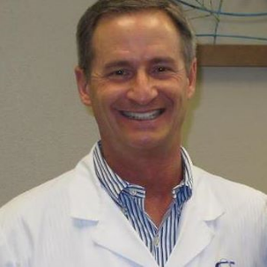**~ John Cornali – 108th Annual Session, The Dental Showcase– Speaker  
Speaker Bio:** Dr. John Cornali grew up in Silver City NM and considers himself a NM native.  He graduated from Western NM University in 1977 and UMKC School of Dentistry in 1981.  Dr Cornali received the John and Ruberta Weaver award for Excellence in Periodontics and Prosthodontics at UMKC.  He returned to his home town of Silver City to practice general dentistry for 18 years. During that time Dr Cornali maintained operating room and hospital privileges as a dental staff member at Gila Regional Medical Center in Silver City.  

Dr Cornali returned to school in 1999 to specialize in orthodontics and received his certificate and Master’s Degree in Orthodontics and Dentofacial Orthopedics from Loma Linda University in 2001.  Upon graduation, he received the Roland D Walters Annual Orthodontic Research Award for his graduate research project and thesis titled: "A Continued Investigation of Craniofacial Growth in Infant Heart Transplant Recipients Receiving Cyclosporine". In June of 2001 Dr Cornali took over Dr Mark Gorham's NE Albuquerque family orthodontic practice and has helped over 3000 children, adolescents and adults achieve beautiful, healthy smiles.  Cornali Orthodontics offers patients conventional clear and metal braces, Invisalign and Invisalign Teen with impression free Digital Scanning, Lingual (hidden) braces, Orthognathic Surgical orthodontics, Wilckodontics accelerated tooth movement, TMJ disorder treatment, and CBCT advanced 3D imaging.  Dr Cornali was chosen Albuquerque the Magazine Top Orthodontist by his dental colleagues in 2009, 2010, 2013.

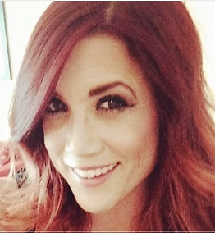**~Stephanie Dominguez – 108th Annual Session, The Dental Showcase– Speaker   
Speaker Bio:** Stephanie Dominguez, an 18-year dental industry veteran, has had a wealth of experience in every aspect of dentistry. She began her career as a dental assistant, graduated as Valedictorian from the University of New Mexico School of Dental Hygiene in 2005 where she then practiced in both corporate and private settings, and has now worked in the dental implant industry for 4 years with OCO Biomedical after spending a few years as a Technology Advisor for Patterson Dental.  An advocate for the profession, she applies her practical knowledge about the industry to create, build, and maintain relationships with practicing dentists and their staffs. Stephanie has been active in the local and state dental associations serving as President of the New Mexico Dental Hygienists' Association, FY 2012-2013.

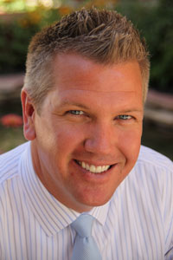**~Andrew Eberhardt– 108th Annual Session, The Dental Showcase– Speaker  
Speaker Bio:** In 1999 Mr. Eberhardt was hired by the Dental Cooperative as Vice President. His responsibilities and duties have largely included managing membership growth and development. He has been key in negotiating and managing purchasing contracts and agreements for Cooperative members.  Historically, these companies include Henry Schein, Procter and Gamble, Komet, Ultradent, Dentsply, Dental Health Products, Inc. and Keystone Implants.  He also leads the negotiation efforts with third party dental insurance partners in obtaining enhanced fee schedules for Co-Op members.

In 2003, Andrew was assigned to develop and directa Co-Op sponsored dental insurance plan to compete with existing plans in the Utah market. Over the next three years “DentistDirect Dental Plans” grew a panel of over 500 dentists and provided dental insurance coverage to thousands of patients throughout the State.  Through that experience birthed a new concept and opportunity for the Co-Op to create a powerful and unique alternative to traditional dental insurance, the Dental Benefit Program.Mr. Eberhardt worked closely with his colleagues and Co-Op dentists to develop the DBP which now has close to 25,000 individual participants and over 500 sponsoring groups spanning across four different states. In the spring of 2012, Andrew was promoted to Chief Operating Officer and directs all operational aspects of the Dental Cooperative.

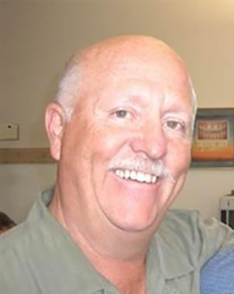**~ Gary Fichtner – 108th Annual Session, The Dental Showcase– Speaker  
Speaker Bio:** Gary Fichtner, CDT, BDT. - If there is a better way to significantly impact the level of care you provide to your patients – Gary will discover it and bring it to the industry. He holds memberships in the Richard V. Tucker international Study Groups, National Association of Laboratories, and the American Academy of Cosmetic Dentistry.

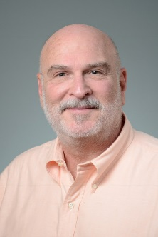**~ Jeffrey Fraum – 108th Annual Session, The Dental Showcase– Speaker  
Speaker Bio:** Jeff Fraum is a Senior Associate General Counsel for the American Dental Association and has been with the ADA since December, 2007. Jeff received his law degree from Rutgers University School of Law-Newark and his undergraduate degree from Haverford College. He is currently admitted to the bars of New Jersey and Illinois, and is a member of the Association of Corporate Counsel.

**~Howard Glazer – 108th Annual Session, The Dental Showcase– Speaker   
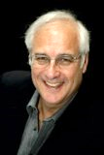Speaker Bio:**  Dr. Glazer is a Fellow and Past President of the Academy of General Dentistry, and former Assistant Clinical Professor in Dentistry at the Albert Einstein College of Medicine (Bronx, NY). He has been a visiting clinician at several universities around the country. He is a Fellow of the American College of Dentists; International College of Dentists; American Society for Dental Aesthetics, the American Academy of Forensic Sciences, and a Diplomate of the American Board of Aesthetic Dentistry. Dr. Glazer is an Attending Dentist at the Englewood Hospital (Englewood, NJ). Additionally, Dr. Glazer is the Deputy Chief Forensic Dental Consultant to the Office of Chief Medical Examiner, City of New York.  
  
For the past several years, Dr. Glazer has been named as one of the “Leading Clinicians in Continuing Education” by Dentistry Today, and most recently was named as one of the Top Dentists in New Jersey by New Jersey Monthly & 201 Magazine. He lectures throughout the United States, Canada, and overseas, on the subjects of dental materials, cosmetic dentistry, forensic dentistry and patient management. Additionally, Dr. Glazer is a frequent author of dental articles and has been published throughout the world. Currently he publishes a monthly column in AGD IMPACT entitled “What’s Hot and What’s Getting Hotter!” He maintains a general practice in Fort Lee, NJ.

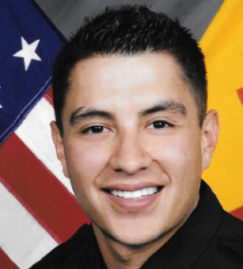**~ Joseph Griego– 108th Annual Session, The Dental Showcase– Speaker   
Speaker Bio:** Joseph Griego is the founder and owner of CAREtactics CPR, a medical instruction company. Joseph is 26 years old and was born and raised in the beautiful north valley of Albuquerque, New Mexico. After serving in the US Navy, Joseph has taken on careers as both an Albuquerque area Firefighter and a local Police Officer. Joseph is a proud father who spends his time coaching his sons little league team and volunteering as a coach for Special Olympics. Joseph's vision for CAREtactics is to provide members of his community with the skills and knowledge necessary to react in an emergency situation so we have a safer environment for all.

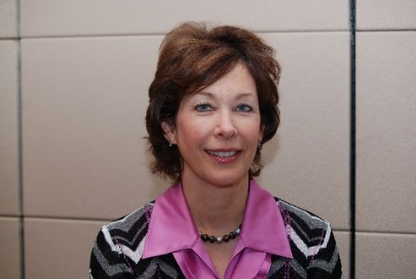**~ Jane Grover – 108th Annual Session, The Dental Showcase– Speaker  
Speaker Bio:** Dr. Jane Grover became the Director of the Council on Access Prevention and Interprofessional Relations for the American Dental Association in April 2013. She is a native of Detroit and received both her dental degree and Master’s Degree in Public Health from the University of Michigan. Prior to joining the ADA, Dr. Grover was the Dental Director of an FQHC in Michigan, adjunct faculty of the University of Michigan School of Dentistry and AEGD residency director for Lutheran Medical Center.

Dr. Grover has been an advocate for public – private partnerships to promote oral health programs for underserved populations. She was awarded the Clinician of the Year award from the Michigan Primary Care Association in 2004 for her role in advocating for the return of dental Medicaid benefits for adults in Michigan. She testified before a US Congressional Subcommittee on dental Medicaid benefits for underserved populations in 2008.

She was also a Trustee in the Michigan Dental Association, Chair of the American Dental Association Political Action Committee and served as ADA Vice President from 2006-2008. She was awarded the distinguished Alumni of the Year award by the University of Michigan School of Dentistry in 2014.

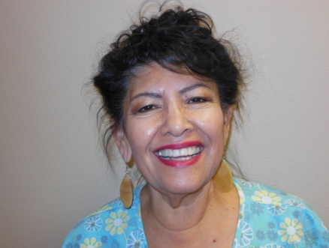**~ Bernadette Jojola – 108th Annual Session, The Dental Showcase– Speaker  
Speaker Bio:** Bernadette Jojola, CDA, has worked with Quality Health Management, providing instruction in many of the Continuing Education courses, for many years. She has a passion for teaching and helps individuals in acquiring knowledge in Dental Radiography to enable one to challenge the Radiation Health and Safety, Infection Control and General Chairside Assisting Exams administered by the Dental Assisting National Board.

**~ Dan Klemmedsen – 108th Annual Session, The Dental Showcase– Speaker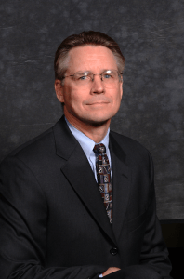Speaker Bio:** Dr. Klemmedson has been in Tucson since 1966.  After completing his undergraduate education at the University of Arizona, he moved to Los Angeles for his dental, medical and surgical training.  He received both his dental and medical degree from the University of Southern California (USC), graduating with honors in both fields.  He completed his oral and maxillofacial surgery training at Los Angeles County/USC Medical Center.  He is board certified and has been a Diplomat of the American Board of Oral and Maxillofacial Surgery since 1985.  He maintains hospital privileges at Tucson Medical Center and University of Arizona Medical Center.  He has held teaching positions at University of Arizona College of Medicine and Pima Community College.  He is a member of the American, Arizona and Southern Arizona Dental Associations (past president of Arizona and Southern Arizona), American Association Oral and Maxillofacial Surgery, Western Society of Oral and Maxillofacial Surgeon (past president), American Cleft-Palate Craniofacial Association, Arizona Society of Oral and Maxillofacial Surgeons (past president) and the Pima County Medical Society.  Dr. Klemmedson plays an active role on the cleft lip and palate/craniofacial team in southern Arizona, which is associated with Children’s Rehabilitative Services.

**~ Antonio Mancusso – 108th Annual Session, The Dental Showcase– Speaker   
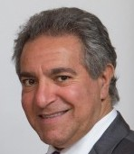** **Speaker Bio:**  Dr. Mancuso graduated from the University of Toronto in 1985 and has maintained a general dental practice in Welland, Ontario ever since. He is a fellow of the following: - the Academy of Dentistry International, the Pierre Fauchard Academy, and the International Academy for Dental Facial Esthetics. In 2006 he received the award of Master in the Academy of General Dentistry and in 2011 he was recognized with the “Lifetime Learning and Service Recognition Award” by the AGD.

He has published articles for numerous dental journals and has given over 100 presentations to various dental organizations in Canada, the United States and internationally. From 1999 to 2009, Dr. Mancuso conceived, developed and ran "Millennium Aesthetics”- a live hands-on program that taught dentists and staff aesthetic diagnosis and treatment. Today, he provides this program to dentists in an over-the-shoulder mentorship format. He is the past Trustee for Canada in the AGD, the Past President of the Ontario AGD and past-Mastertrack Director of the OAGD. He is also the Past-President for the Niagara Peninsula Dental Association – a component society of the ODA. He currently serves as President of the Regional Niagara AGD study club. In 2012 he was named, “Canadian AGD Dentist of the Year” by the Canadian AGD.

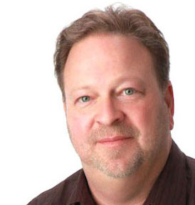**~ Michael McDade – 108th Annual Session, The Dental Showcase– Speaker  
Speaker Bio:** Michael McDadeis CEO of Focus Creative Agency, Albuquerque, NM. Michael is an expert in marketing and dental practice development and has many years of experience helping dentists to be more successful. He is a seasoned public speaker and a Certified WHY Coach.

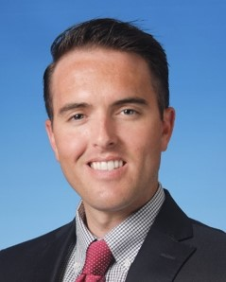**~ Drew McDonald – 108th Annual Session, The Dental Showcase– Speaker  
Speaker Bio:** Dr. Drew McDonald is thrilled to be speaking at the NMDA Annual Session for the first time. Dr. McDonald is an alumnus of the University of New Mexico where he was a varsity catcher for the Lobo Baseball team. He is a proud former member of the UNM Pre-Dental Society and graduated from UNM in 2008. Dr. McDonald earned his dental degree from Creighton University in 2014 and went on to complete his orthodontic residency at the University of Missouri – Kansas City in December of 2016. He received his orthodontic specialty certificate and master’s degree in Oral and Craniofacial Sciences with his original clinical research thesis investigating the effects of sports mouth guards on the temporomandibular joint complex. Dr. McDonald also worked as a general dentist during his 2.5-year residency program.

In January 2017, Dr. McDonald joined Dr. John Cornali as a partner at Cornali and McDonald Orthodontic Specialists in the NE heights of Albuquerque. In addition to traditional braces, Dr. McDonald has extensive training and experience utilizing the latest technologies and techniques in orthodontics. Dr. McDonald has special interests in the areas of sports dentistry, accelerated orthodontics, and providing care for patients with special needs, specifically, Autism Spectrum Disorder, which his oldest daughter is affected by.

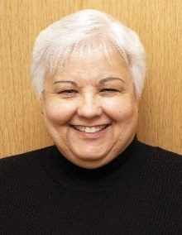**~ Jane McGinley – 108th Annual Session, The Dental Showcase– Speaker**   
**Speaker Bio:** Jane McGinley is a dental hygienist with an MBA who is manager for Fluoridation and Preventive Health Activities at ADA for the Council on Advocacy for Access and Prevention. Prior to working for the ADA, Jane was in private clinical practice for 15 years and spent another 15 years serving as dental health coordinator in a residential facility for individuals with special needs. With more than 19 years’ experience in dealing with the science, challenges and strategies surrounding fluoridation, Ms. McGinley provides technical assistance to ADA members, key stakeholders and coalitions. Additionally, she facilitates the work of the National Fluoridation Advisory Committee.

**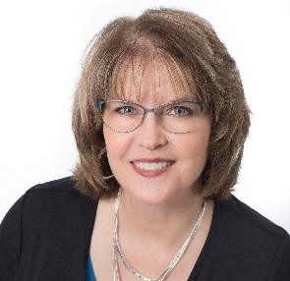  
~ Kim Miller – 108th Annual Session, The Dental Showcase– Speaker  
Speaker Bio:** Kim Miller, RDH, BSDH is a Lead Profitability Coach with Inspired Hygiene, a national speaker, co-founder of PerioFrogz.com and a columnist for RDH magazine. Graduating from Loma Linda University in 1981 with a Bachelor’s Degree in Dental Hygiene, Kim is also a four-time graduate of the Bale/Doneen Mentor Preceptorship Program. In addition to clinical practice, Kim has more than 25 years of coaching experience. She has mentored hundreds of dental professionals in workshop and private practice settings. Kim is passionate about helping clinicians adopt solid science based principles and treatment philosophies resulting in exceptional treatment outcomes, healthier patients and happier more satisfied clinicians.

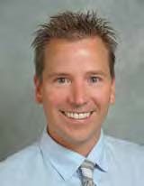**~ Chris Morgan – 108th Annual Session, The Dental Showcase– Speaker  
Speaker Bio:** Chris Morgan, DMD, Private Practice General Dentist, Santa Fe. After graduating from Allegheny College in Pennsylvania, Dr. Morgan attended the University of Pittsburgh School of Dental Medicine, graduating in 2001. He practiced general dentistry in Michigan for nine years before relocating to Santa Fe in 2010. He was awarded the Golden Apple Award from the ADA in 2010, recognizing strong legislative action in his community. As President Elect, Dr. Morgan will be next in line to assume the NMDA Presidency.

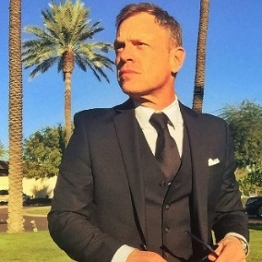**~ Michael Moxey – 108th Annual Session, The Dental Showcase– Speaker  
Speaker Bio:** Michael brings over 20 years of communications, broadcasting and government experience to his position at the NMDA.  His background includes holding the position of Public Information Officer for the New Mexico Economic Development Department, Director of Charitable Giving and Communications for Charter Bank, and a dozen years as an award winning broadcaster in Albuquerque and Austin.  In his spare time he records and performs music with his band, can be heard on commercial radio/television voiceovers, and is an avid photographer.   

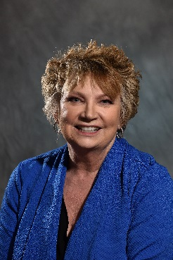**~ Linda Nichols – 108th Annual Session, The Dental Showcase– Speaker  
Speaker Bio:** Linda Kay Nichols, DMD, PA graduated from Tufts School of Dental Medicine, and has been in private practice for many years. She belongs to the oldest Study Club west of the Mississippi, is a recent member of the American Association of Dental Practice Administration and the American Association of Facial Esthetics, as well as the tripartite of dentistry---ADA, NMDA and ADDS.

She has walked off of a 870 foot building, co-authored a book, and rafted the Colorado River through the Grand Canyon. She is a strong supporter of the United States Constitution and the Second Amendment. Having stood within the walls of the United States Supreme Court and the Lincoln Memorial, she is prideful at the singing of the United States National Anthem. This is the second time she has presented at the New Mexico Dental Association on the subject of Ethics.

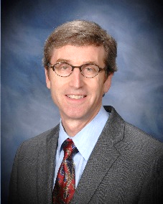**~Jonathan Parker – 108th Annual Session, The Dental Showcase– Speaker  
Speaker Bio:** Dr. Parker is a graduate of the University of Minnesota School of Dentistry. He has treated patients with snoring and sleep apnea for over 24 years and has had a full-time practice in dental sleep medicine in Minneapolis, Minnesota since 2001. He is a Diplomate of the American Board of Dental Sleep Medicine and the American Board of Orofacial Pain. He is a charter member of the American Academy of Dental Sleep Medicine. He was the recipient of the Academy’s prestigious Distinguished Service Award in 2003. He is immediate past President of the American Board of Dental Sleep Medicine.

Dr. Parker is an Adjunct Clinical Professor at Tufts University School of Dental Medicine. He has authored a number of research articles and abstracts evaluating the effectiveness of oral appliance therapy for obstructive sleep apnea (OSA). Dr. Parker has lectured internationally on evaluation and treatment of snoring and OSA. He is well known for developing innovative techniques and protocols to improve patient care and treatment success in dental sleep medicine.

**~ Howard Pollick – 108th Annual Session, The Dental Showcase– Speaker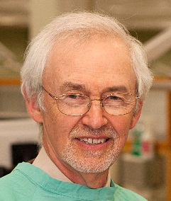Speaker Bio:** Dr. Howard Pollick is a licensed dentist in California, a health sciences clinical professor and director of the dental public health residency program, Department of Preventive & Restorative Dental Sciences, School of Dentistry at the University of California San Francisco.

Dr. Pollick has lectured extensively on the benefits and safety of community water fluoridation in California, nationally and internationally. He has been a Past Chair of the Oral Health Section and Governing Councilor of the American Public Health Association.

A diplomate of the American Board of dental public health (since 1985), Dr. Pollick is an American Dental Association expert spokesperson on fluoridation (since 2004), a member of the ADA National Fluoridation Advisory Committee, chair of the fluoridation advisory committee to the California Dental Association Foundation and a consultant to the California Department of Public Health. He is the recipient of the 2010 Fluoridation Special Merit Award from the Association of State and Territorial Dental Directors and the 2015 recipient of the UCSF Chancellor’s Award for Public Service.

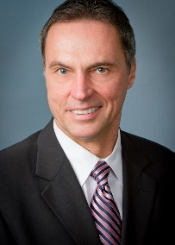**~ Dan Poticny – 108th Annual Session, The Dental Showcase– Speaker  
Speaker Bio:** Dr. Poticny is a clinical associate professor at the University Of Michigan School Of Dentistry with a private practice in Grand Prairie, TX. He is a graduate of the Ohio State University, the Baylor College of Dentistry and a fellow of the Academy of CAD/CAM Dentistry. He is a member of the American Dental Association, Academy of General Dentistry, the International Association for Dental Research, and the International Society of Computerized Dentistry.  
  
Dr. Poticny’s areas of professional interest include digital dentistry and material clinical applications. He is one of the earliest to incorporate CAD/CAM chairside concepts to his dental practice beginning with CEREC 2 which has led to his current involvement at the academic and research level with a variety of digital systems. He has written numerous articles, research papers, and scientific abstracts on the accuracy, efficacy, and clinical outcomes for these systems and has presented worldwide on these topics. Since 1999 he has taught dentists the use of these systems, applications of modern dental materials, and adhesive dentistry for the everyday dental practice.

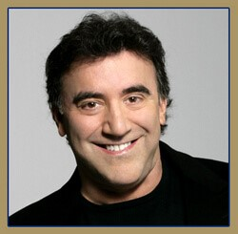**~ Steve Rasner – 108th Annual Session, The Dental Showcase– Speaker  
Speaker Bio:** In 1981, Owens-Illinois, the 6th largest glass plant in the world, closed its doors. What followed was a domino effect of failed businesses, staggering unemployment and a devastatingly bleak economy. That was the year after Dr. Steven Rasner opened his practice in southern New Jersey. Sadly, 34 years later, this area has remained nationally ranked for its unemployment, poverty levels and absence of growth. During this same time period, Dr. Rasner has nurtured a private feefor- service practice that commands fees in the top percentile in the nation. It grosses over 4.1 million per year on a four-day work week with a part time associate and a substantial bottom line. The practice has been a leader in community civic duty and was awarded the Congressional Recognition Award in 2000.

Dr. Rasner has taught for seventeen years in 40 American states and 5 countries. He has received numerous speaking awards and been recognized in Dentistry Today’s Top Clinical Educators list for ten consecutive years. Dr. Rasner received a lifetime achievement award in 2011 from Excellence in Dentistry. He has authored 3 books and over 50 industry and journal publications.

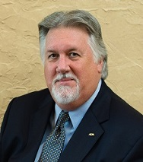 **~Gary L. Roberts - 108th Annual Session, The Dental Showcase– Speaker  
Speaker Bio:** Dr. Gary Roberts is the 153rd president of the American Dental Association, the nation’s largest dental association, representing 159,000 dentist members. He attended Baylor College of Dentistry, now Texas A&M College of Dentistry, and established his dental practice in Shreveport, Louisiana. He has been an ADA member for 41 years.

Dr. Roberts is a member of the Academy of General Dentistry and Ark-La-Tex Academy of Dentistry. He is a fellow of the American College of Dentists, International College of Dentists and the Pierre Fauchard Academy. He is also a past president of the Louisiana Dental Association and former editor of the Journal of the Louisiana Dental Association.

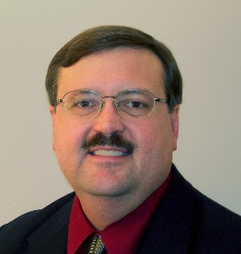**~ Thomas Schripsema – 108th Annual Session, The Dental Showcase– Speaker  
Speaker Bio:** Tom. Schripsema, DDS, NMDA Executive Director.  Tom is a third-generation New Mexican. After graduating from Manzano High School, Tom attended Calvin College in Grand Rapids, MI, receiving a BA with a major in biology and significant coursework in chemistry and music. He continued doctoral studies at Creighton University in Omaha, NE graduating with a DDS in 1983. He has been in private practice here in Albuquerque for 34 years, which also included two years as a part-time civilian dentist at Kirtland Air Force Base clinic. He took over as Executive Director one year ago, but continues to keep his fingers wet on a part-time basis.

Dr. Schripsema is a past president of the New Mexico Dental Association and the New Mexico Academy of General Dentistry. He was vice-chairman of the American Dental Association’s Council on Dental Benefits Programs and served on the ADA Code Revision Committee for six years. He was a delegate or alternate delegate to the ADA for 20 years and served as the NMDA Government Affairs chair for 16 years. Tom has lectured around the country on subjects relating to dental benefits, coding and peer review. He also contributes to state and national dental periodicals and publications.

When not engaged in Dental Association business or fixing teeth, he performs regularly on french horn with the Albuquerque Concert Band, Concordia Santa Fe, the Brasso Profundo brass quintet and other community music groups.

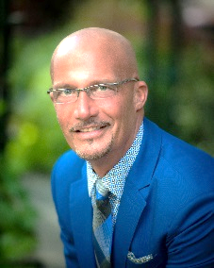**~ Roy Shelburne – 108th Annual Session, The Dental Showcase– Speaker   
Speaker Bio:** Born in Pennington Gap, VA, I was "raised" on a farm in rural southwest Virginia. Growing up there I learned to love the people and the scenery of the Appalachian Mountains. The second of 4 boys born to a High School agriculture teacher and a registered nurse, working on the farm instilled the importance of hard work. I'm deeply thankful to my parents for the example they set for me. I graduated from Pennington High School in 1973, with honors, and was accepted and enrolled at the University of Virginia, Charlottesville the fall semester of that same year. I was a 1977 graduate of the University of Virginia with a double major in Biology and Religious Studies. I applied, was accepted to, and enrolled in the dental school at Virginia Commonwealth University and graduated with honors in 1981, 5th of 115. I returned home in 1981 to start my new practice in my grandfather's hardware store building.  
  
Serving organized dentistry as a former Secretary/Treasurer and President of the southwest Virginia, Component 6, Virginia Dental Association I learned the importance of giving back to the profession. I was honored to be been made a delegate to the Virginia Dental Association's Annual Meeting. I also learned the importance of volunteerism.... giving back to my community, state, and world as I had been so richly blessed. I have served for over 7 years with the various Mission of Mercy projects in Virginia and have been a member of a team of short term missionaries with the Baptist Medical Dental Missions International to Honduras, CA for 10 years. All this happened prior to the voluntary surrender of my dental license for revocation after the conviction and prior to sentencing.

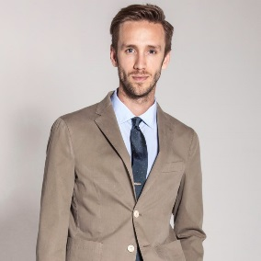**~ Kyle Stanley – 108th Annual Session, The Dental Showcase– Speaker**   
**Speaker Bio:** Dr. Kyle Stanley graduated Magna Cum Laude from the Herman Ostrow School of Dentistry of USC and. then went on to complete a dental implant residency along with a dental implant specialty in Florianopolis, Brazil. While at USC, Dr. Stanley completed an 18-month Esthetic Selective program with the world leader and “father” of minimally invasive Biomimetic dentistry, [Dr. Pascal Magne](http://www.beverlyhillsladentist.com/pascal-magne/), and was honored with the Charles L. Pincus Award for outstanding achievements in esthetic dentistry by the American Academy of Esthetic Dentistry.

In addition to Dr. Stanley’s clinical artistry, he is also a dedicated researcher who has been [published in some of the top international dental journals](http://www.beverlyhillsladentist.com/scientific-contributions/) about topics relating to esthetics, minimally invasive treatment, dental materials, dental implants, and surgery. Because of his research and expertise, Dr. Stanley has presented in the USA, Mexico, and Brazil and was a Stevens Institute for Innovation Most Innovative Research Nominee, California Dental Association Table Clinic; Clinical Science Winner, USC DDS Research Clinical Science Winner, USC Graduate and Professional Student Senate Poster Symposium Award Winner, and has even appeared on Smiletalk Radio as a special guest expert.

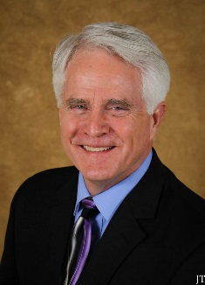**~ Tim Twigg – 108th Annual Session, The Dental Showcase– Speaker  
Speaker Bio:** Tim Twigg is the President of Bent Ericksen & Associates. Bent Ericksen & Associates has been the leading authority in human resources and personnel management in the healthcare industry, helping dentists successfully deal with the ever-changing and complex labor laws. Tim brings over 30 years of practice management and business consulting experience and knowledge specifically in the healthcare field. Tim’s expertise extends to leadership and business development, strategic planning and marketing, and communication skills. He has presented seminars nationally on practice management, human resources, and employment compliance.

Tim is a published author and currently co-authors a regular column in Dental Economics entitled: “Staff Issues”. He is part of the management faculty and/or speakers’ bureau for: Career Fusion, Seattle Study Club, Hygiene Fusion, Jameson Management, and LVI Global. Tim is the past president of and a member of the Academy of Dental Management Consultants and a member of the Speaking Consulting Network. He is a member of the Society for Human Resources Management and VetPartners, the professional consulting association for the veterinary industry.

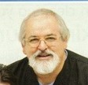**~ Joe Valles – 108th Annual Session, The Dental Showcase– Speaker  
Speaker Bio:** Joe L. Valles D.D.S., has practiced General Dentistry in Albu­querque for 35 years. His son, Domingo Valles DDS, joined the practice in 2010. Dr. Valles was raised by grandparents in Jarales, New Mexico; attended schools in Jarales, Belen, and Albuquerque’s South Valley. A high school drop-out; Dr. Valles served in the U.S. Army and in the Volunteers in Service to America (VISTA) program. Dr. Valles went on to graduate with Distinction from the University of New Mexico and Cum Laude from the University of Southern California School of Dentistry. Known to many as ‘Dr. Joe,’ he is a strong advocate for neighborhood associations and the common person. As Vice-President, Dr. Valles will be next in line to assume the NMDA Presidency.

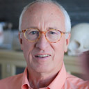**~ Stephen Wagner – 108th Annual Session, The Dental Showcase– Speaker  
Speaker Bio:** Dr. Stephen Wagner, a Diplomate of the American Board of Prosthodontics, a Fellow of the Academy of Maxillofacial Prosthetics and a Fellow of the Academy of Prosthodontics, is currently in his 39th year of private practice in Albuquerque, New Mexico.

He received his dental degree from the University of Southern California School of Dentistry and his prosthodontic training from MD Anderson Hospital in Houston, Texas. Dr. Wagner serves on the Review Board of the International Journal of Oral and Maxillofacial Implants, the Board of Directors of the American College of Prosthodontists and is Editor of the ACP Board Study Guide.

Steve is a Key Opinion Leader for both Dentsply Sirona Prosthetics and Global Dental Science, the home of the Avadent digital denture. Dr. Wagner was awarded the prestigious 2014 Private Practice Award by the American College of Prosthodontists.

Dental images taken by Dr. Wagner have been used in medical and dental textbooks and by the New York Times, ABC News, Newsweek, and The American Dental Association in the Journal of the American Dental Association, ADA educational pamphlets, on the ADA web site.

**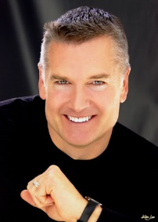  
~ Byron Wall – 108th Annual Session, The Dental Showcase– Speaker  
Speaker Bio:** Considered one of the best cosmetic dentists in the Albuquerque area, Byron W. Wall DDS consistently produces high quality results for his patients using the most sophisticated and efficient dental equipment available in [cosmetic](http://www.cosmeticdentistryofnewmexico.com/cosmetic-dentistry) and [restorative dentistry](http://www.cosmeticdentistryofnewmexico.com/restorative-dentistry). Also, by employing the most skilled professionals in the field of dentistry our facility is able to stay a step ahead of the rest. Your dental health is important. If you’re looking for superior care, before, during and after your procedure, we encourage you to contact cosmetic dentist Byron Wall in Albuquerque, New Mexico.

Dr. Byron W. Wall earned his Bachelor of Science degree from the University of Iowa in 1978. He went on to earn his Doctor of Dental Surgery from the University of Iowa in 1982, and completed his general practice residency at Illinois Masonic Medical Center the following year. Dr. Wall is also a graduate of the Las Vegas Institute Continuum, the world's premier post-graduate educational center for advanced dental studies. Graduates of LVI are considered to be among the finest dentists in the world. As past president of the Albuquerque District Dental Society, Dr. Wall remains very active in the dental community and is committed to continuing education for both himself and his team.

Dr. Wall has been in private practice as a cosmetic dentist in Albuquerque since August 1983. He is licensed by the state of New Mexico.

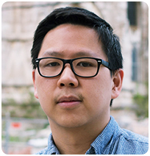**~Ron Wang – 108th Annual Session, The Dental Showcase– Speaker   
Speaker Bio:** Dr. Ron Wang received his D.M.D degree from the University of Pennsylvania, School of Dental Medicine where he graduated with honors. He went on to complete a General Practice Residency at the Philadelphia VA Medical Center, where he received intensive training in oral and periodontal surgery, implants and fixed prosthetics. As a dedicated and avid learner of the arts and science of dentistry, Dr. Wang has completed extensive courses in esthetic dentistry, multidisciplinary treatment planning and is a devoted member of the Academy of Osseointegration and Spear Study Club. Dr. Wang regularly lectures on the subjects of periodontal regeneration, guided bone regeneration and surgical site preparation for implant placement.

**~ Andrea Wiseman – 108th Annual Session, The Dental Showcase– Speaker**

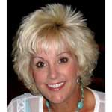**Speaker Bio:** Andrea S. Wiseman, RDH is a National Preventive Specialist for 3M ESPE, and brings over 30 years of experience in dentistry to her presentations. She is a member of the American Dental Hygiene Association, Texas Dental Hygiene Association, and past president of the San Antonio District Dental Hygiene Association and Gulf Coast Dental Hygiene Society of Ft. Myers, FL.