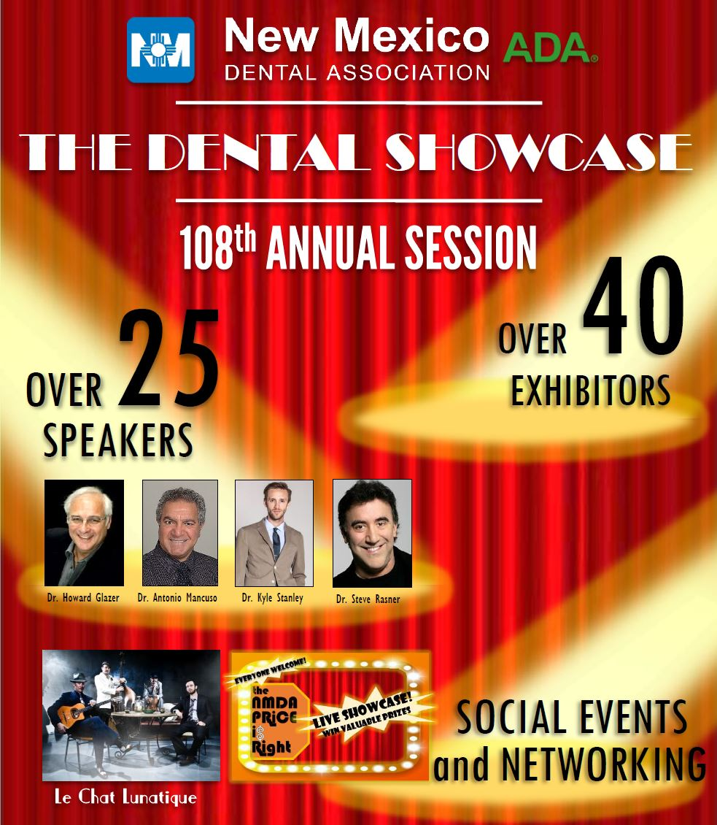

Course Descriptions

|  |  |  |
| --- | --- | --- |
| Prefix | Spkr FN | Spkr LN |
| Ms. | Cathryn | Albrecht |
| Dr. | Christopher | Baer |
| Ms. | Jill | Baskin |
| Dr. | Lionel | Candelaria |
| Ms. | Renee | Cina-Acosta |
| Dr. | John | Cornali |
| Ms. | Stephanie | Dominguez |
| Mr. | Andrew | Eberhardt |
| Mr. | Gary | Fichtner |
| Mr. | Jeffrey | Fraum |
| Dr. | Howard | Glazer |
| Mr. | Joseph | Griego |
| Dr. | Jane | Grover |
| Ms. | Bernadette | Jojola |
| Dr. | Daniel | Klemmedsen |
| Dr. | Antonio | Mancuso |
| Mr. | Michael | McDade |
| Dr. | Drew | McDonald |
| Ms. | Jane | McGinley |
| Ms. | Kim | Miller |
| Dr. | Chris | Morgan |
| Mr. | Michael | Moxey |
| Dr. | Linda | Nichols |
| Dr. | Jonathan | Parker |
| Dr. | Howard | Pollick |
| Dr. | Dan | Poticny |
| Dr. | Steve | Rasner |
| Dr. | Gary | Roberts |
| Dr. | Thomas | Schripsema |
| Dr. | Roy | Shelburne |
| Dr. | Kyle | Stanley |
| Mr. | Tim | Twigg |
| Dr. | Joe | Valles |
| Dr. | Stephen | Wagner |
| Mr. | Joel | Waldman |
| Dr. | Byron | Wall |
| Ms. | Andrea | Wiseman |
| Dr. | Ron | Wang |

**~ Cathryn Albrecht – 108th Annual Session, The Dental Showcase– Speaker**

**Title: Participating Provider Contracts: The Basics, Relevant Issues and Golden Rules - Sponsored by ADA  
Date: Saturday June 10, 2017 9:00am – 10:30am Location: 240/LA CIENEGA CEUs: 1**

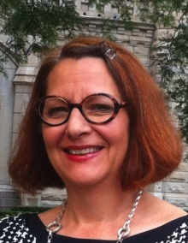**COURSE DESCRIPTION:** The lecture will analyze contract terms contained in dental provider agreements, in order to give attendees information to use in making informed decisions. The lecture will also discuss antitrust concerns, federal and state laws, and other current issues.

**Objectives:**

* Upon completion, participant will be able to better understand and analyze participating provider contract terms
* Upon completion, participant will understand antitrust concerns related to participating provider contracts.
* Upon completion, participant will understand legal concerns, including various federal and state laws, related to participating provider contracts.

**Title: Dentist Employment Agreements: A Guide to Key Legal Provisions - Sponsored by ADA  
Date: Saturday June 10, 2017 10:30am – 11:30am Location: 240/LA CIENEGA CEUs: 1**

**COURSE DESCRIPTION:** Course has been delivered on behalf of ADA at numerous dental schools (well over a dozen) and for various groups of dental students. The course focuses on educating attendees concerning legal provisions and issues arising from dentist employment agreements. Among the issues and provisions discussed are an employee-dentist’s duty, designation of independent contractor vs. employee, non-competition provisions, non-solicitation, malpractice insurance, dispute resolution, negotiation strategies, and the importance of attorney review of the employment agreement.

**Objectives:**

1. Upon completion, participants will be able to identify and understand the importance of key provisions that appear in dentist employment agreements, such as non-competition and independent contractor vs. employee.
2. Upon completion, participants will understand basics of negotiation of a proposed agreement.
3. Upon completion, participants will understand the importance of retaining an attorney to assist, as well as how to interview and select an attorney.

**~ Christopher Baer – 108th Annual Session, The Dental Showcase– Speaker**

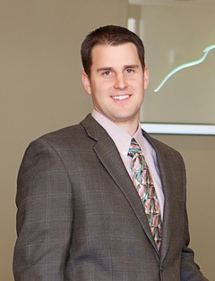**Title: Going Digital: Improving Clinical Efficiency with Digital Impressions - Sponsored by Benco**

**Date: Friday June 9, 2017 9:00am – 12:00pm Location: 235/Mesilla CEUs: 3**

**COURSE DESCRIPTION:** Improving Clinical Efficiency with Digital Impressions

**Objectives:**

* learn about the different types of digital impression systems
* how to be successful with scanning
* how to incorporate scanning technology into the practice

**~ Jill H. Baskin – 108th Annual Session, The Dental Showcase– Speaker**

**Title: CNA Dental Professional Liability Risk Management Seminar- Sponsored by Brown and Brown of New Mexico  
Date: Thursday June 8, 2017 9:00am – 12:00pm Location: 240/LA CIENEGA CEUs: 3**

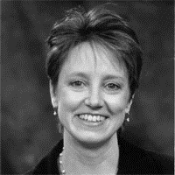**COURSE DESCRIPTION:** In today’s litigious society, managing risk is critical. Don’t wait until after you’ve had a malpractice claim to learn the most effective ways to protect your patients – and your practice. This is a great opportunity to learn from the experiences of your colleagues, as the presentation and discussion of actual claims lead you through a myriad of key risk exposures. A sampling of the course topics includes:

* Pre-treatment issues, including the medical history, examinations, and radiography.
* Best practices for managing clinical risks.
* Creating patient records that document and support your care.
* Informed consent and informed refusal.
* Terminating the dentist-patient relationship.
* Managing adverse events, and much more.

The presentation will provide you with skills, tips and techniques to better manage patients and your practice. Its goal is to stimulate you to assess your practice, apply critical thinking based on the information presented, and make prudent choices that enhance patient care and reduce your chance of a malpractice claim. Each attendee will receive a comprehensive course workbook that makes a great reference resource to have at the office.

There’s something in the course for everyone, whether you’re learning new techniques or simply validating the good risk management protocols you already follow.

**Objectives:**

Upon completion of this course, participants should be able to:

* Assess and update risk management practices they currently use.
* Understand that the ultimate result of improved risk management is improved patient care.
* Make the informed consent process a critical success factor in patient management.
* Understand risk management implications of the doctor-patient relationship.
* Implement record keeping practices that enhance patient care and reduce malpractice risks.

**~Lionel Candelaria – 108th Annual Session, The Dental Showcase– Speaker**

[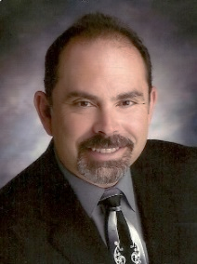](http://www.omsanewmexico.com/files/2011/08/Lionel-Candelaria-pic.jpg)**Title: Current Concepts in Post-Operative Pain Management  
Date: Thursday June 8, 2017 2:00pm – 5:00pm Location: 240/La Cienega CEUs: 3**

**COURSE DESCRIPTION:** Guidelines for prescribing analgesic medication with consideration for effective postoperative pain control, minimizing potential adverse reactions and managing side effects. Review of surgical techniques for frequently preformed dentoalveolar procedures effectively minimizing tissue damage and reducing time from incision to closure thereby, decreasing the need for opioid analgesics. This course fulfills NM dental board requirement for three continuing education hours in pain management.  
 **OBJECTIVES:**

1. Review the NM Pain Relief Act and NMAC 16.5.57.
2. Review of the NM prescription drug monitoring program.
3. FDA guidelines for proper drug disposal.
4. Understanding the consequences of opioid diversion.
5. Relevant discussion of opioid and non-opioid analgesics pharmacology.
6. Review common analgesic drug interactions.
7. Examination of opioid addiction physiology.
8. Management of the common opioid adverse drug reactions and allergic reactions.
9. I depth discussion of the World Health Organization “analgesic ladder,” a stepwise approach to treating mild to severe pain and evolving opioid abetment strategies.
10. Clinical pearls and refined surgical technique for frequently preformed dentoalveolar procedures.
11. Pain management strategies for patients with a reported history of substance abuse.

**~Renee Cina Acosta – 108th Annual Session, The Dental Showcase– Speaker**

**Title: Two for The Team: What to Know About Implants & Regeneration   
Date: Friday June 9, 2017 9:00am – 12:00pm Location: 220/Ruidoso CEUs: 3**

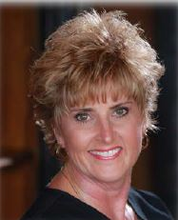**COURSE DESCRIPTION:**  This program focuses on establishing periodontal therapies in your hygiene department. There will be discussion of the different types of regenerative therapies. Participants will be provided with tools to improve periodontal therapy and explore the advances and benefits of periodontal regeneration. Participants will understand the basis and need for identification before it is too late and how to communicate this to patients.

Attendees will be engaged in learning more about implants, the basic types & components, then the types of instruments to be used with those implants. Understanding more about implants and their biocompatibility with the human body is a must for today’s practice. We will delve into identification of diseased implants and implement a system that can be incorporated into your practice for identification purposes.

**OBJECTIVES:**

1. Implement systems to create a periodontally aware practice.
2. Establish evidence-based periodontal treatment protocols.
3. Understand the biologic basis for bone and soft tissue responses.
4. Understand the indications, method of use and regenerative potential of enamel matrix derivative and other biologic modifiers & lasers.
5. Implement effective communication to help treatment acceptance.
6. Identify the basic types & components of a dental implant.
7. Understand the importance of post-treatment care for the implant patient.
8. Understand biocompatibility of materials in implant maintenance & proper instrumentation.
9. Identify potential risks & complications.
10. Communicate the importance of regular post-operative care.

**Title: Chew on This: Chronic Inflammation, Nutrition & Your Patients.**

**Date: Friday June 9, 2017 2:00pm – 5:00pm Location: 235/Messilla CEUs: 3**

**COURSE DESCRIPTION:** Systemic diseases are at epidemic proportions around the world. Chronic inflammation is the root cause of systemic disease. Both perio-systemic and oral-systemic links have been well documented in research. Over the past 30 years’ dietary guidelines have changed, and our nation has been bombarded with news reports, books and advice on nutrition, weight loss and how to’s. Statistics are ballooning related to healthy food choices and chronic inflammation.

This program focuses on how food choices have a direct impact on total health. Registered dental hygienists are often are first responders to the inflammatory cascade. The dental team plays an integral part in assessment, coaching and nutritional counseling for dental patients to achieve better overall health. A highlight of this program explains how food choices reduce inflammation and systemic disease.

**OBJECTIVES:**

1. Differentiate chronic/acute inflammation and effects on disease, including periodontal disease.
2. Explain the connection between metabolic disease and chronic inflammation.
3. Discuss evolution of dietary guidelines, current research and evidence.
4. Demonstrate understanding healthy food choices play in reducing chronic inflammation.
5. Describe how proper chewing directly impacts digestion and total health.

**~John Cornali – 108th Annual Session, The Dental Showcase– Speaker**

**Title: The Straight "Tooth Truth" About Orthodontics  
Date: Thursday June 8, 2017 9:00am – 12:00pm Location: 140/Aztec CEUs: 3  
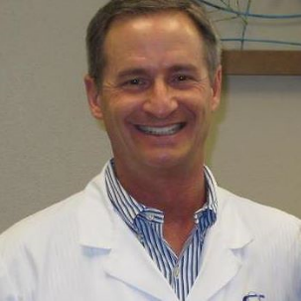COURSE DESCRIPTION:** 'The Straight "Tooth Truth" About Orthodontics’ will be a fast-paced look at the 7 goals of modern day orthodontics, Early orthodontic screening and indications for early treatment and prevention, Extraction vs. Non-extraction treatment, “Wilckodontics” osteogenically accelerated orthodontic tooth movement, Head gear free modern day Class II correction, Surgical orthodontics, Orthodontic pitfalls and 3D computerized cone beam technology benefits.

**OBJECTIVES:** The objective will be to give any dentist, dental hygienist or dental assistant a fast-paced update of the most recent, modern, up to date cutting edge techniques and changes in the specialty field of orthodontics.

**~Stephanie Dominguez – 108th Annual Session, The Dental Showcase– Speaker**

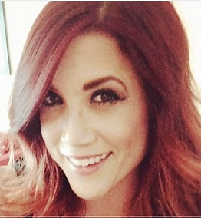**Title: Dental Assistants Dental Implants -Surgical Workshop - Sponsored by OCO Biomedical  
Date: Thursday June 8, 2017 9:00am – 12:00pm Location: 210/Tijeras CEUs: 3**

**COURSE DESCRIPTION:** Learn how to prepare and set-up for surgical placement of dental implants.

**OBJECTIVES:** Hands-on learning provides valuable instruction to experience:

* Office Set-Up for the Implant Surgical Practice
* Patient Preparation
* Operative Room Preparation
* Instrumentarium
* Surgery
* Post-Op Care
* 2nd Stage Procedure
* Clean-Up

**Title: Dental Assistants Dental Implant Prosthetics Workshop - Sponsored by OCO Biomedical  
Date: Thursday June 8, 2017 2:00am – 5:00pm Location: Suite E&F CEUs: 3**

**COURSE DESCRIPTION:** Restoration of implants is a necessity in dental practice, and there are various ways to restore each specific situation.

**OBJECTIVES:** The following techniques and the necessary materials and devices are included:

* Restoring single implants with screw on abutments or directly onto the implants;
* Closed tray and open tray impression copings
* Fixed and removable complete dentures supported with implants;
* Impression techniques

**~Andrew Eberhardt – 108th Annual Session, The Dental Showcase– Speaker   
  
Title:** **Maximizing Insurance Relationships**  **Date: Thursday June 8, 2017 9:30am – 10:30pm Location: Hall 4 – Center of Learning Stage CEUs: 1**

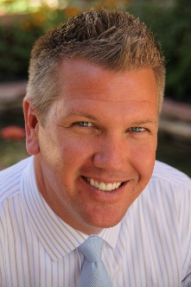**COURSE DESCRIPTION:** Understanding the dos and don’ts of working with dental insurance companies is vital in today’s dental world. Independent dental offices are limited in understanding how to obtain the very best fee schedules in any given market.  Simply put, anti-trust laws prevent dentists from freely collaborating and working directly with insurance companies unless guided under certain safe harbors.  When properly informed, dentists can work together to make sure they are receiving the highest reimbursement rates possible while maintaining a healthy partnership with insurance carriers.

This course will take a deeper look at the history of dental insurance and present optimal initiatives that can help your practice obtain fees that lead to increased practice profitability.  Come join your dental colleagues and team members to participate in a meaningful group discussion about the relationship between dental insurance carriers and dental providers.  You will leave with a greater understanding and some action items to implement immediately.

**OBJECTIVES:** Topics to discuss:

* How do I know I’m getting the best fee schedule without breaking my contract?
* Where can I go to determine if my UCR fees are in line with other dentists?
* Can I negotiate with insurance carriers for enhanced fees?
* What is the difference between umbrella groups and insurance carriers?
* How can a messenger model or IPA assist to help improve my contracted fee schedules?

**~ Gary Fichtner – 108th Annual Session, The Dental Showcase– Speaker**

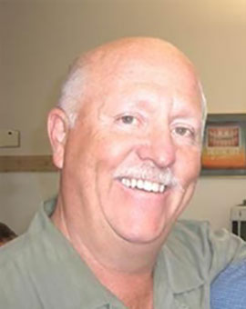**Title: Clon3D presents the Condor Intra-Oral Scanner  
Date: Thursday June 8, 2017 11:00am – 12:00Pm Location: Hall 4/ COL CEUs: 1**

**COURSE DESCRIPTION:** We will be demonstrating a better way to deliver a higher standard of patient care by utilizing the Condor Intra-Oral Scanner. Our goal is to demonstrate how the scanner can be used for diagnosis, presentation of findings for higher patient commitment and creating restorations that provide the best fit and accuracy since the beginning of time.  This leads to deeper trust and relationship with your patient, reduced time and costs per case and a deeper sense of fulfillment and confidence for the dentist, then lab and, most importantly, your patient.

**Title: Clon3D presents the Condor Intra-Oral Scanner  
Date: Thursday June 8, 2017 4:00pm – 5:00Pm Location: Hall 4/ COL CEUs: 1**

**COURSE DESCRIPTION:** We will be demonstrating a better way to deliver a higher standard of patient care by utilizing the Condor Intra-Oral Scanner. Our goal is to demonstrate how the scanner can be used for diagnosis, presentation of findings for higher patient commitment and creating restorations that provide the best fit and accuracy since the beginning of time.  This leads to deeper trust and relationship with your patient, reduced time and costs per case and a deeper sense of fulfillment and confidence for the dentist, then lab and, most importantly, your patient.

**Title: Clon3D presents the Condor Intra-Oral Scanner  
Date: Friday June 9, 2017 10:00am – 11:00am Location: Hall 4/ COL CEUs: 1**

**COURSE DESCRIPTION:** We will be demonstrating a better way to deliver a higher standard of patient care by utilizing the Condor Intra-Oral Scanner. Our goal is to demonstrate how the scanner can be used for diagnosis, presentation of findings for higher patient commitment and creating restorations that provide the best fit and accuracy since the beginning of time.  This leads to deeper trust and relationship with your patient, reduced time and costs per case and a deeper sense of fulfillment and confidence for the dentist, then lab and, most importantly, your patient.

**~ Gary Fichtner – 108th Annual Session, The Dental Showcase– Speaker**

**Title: Clon3D presents the Condor Intra-Oral Scanner  
Date: Friday June 9, 2017 3:00pm – 4:00Pm Location: Hall 4/ COL CEUs: 1**

**COURSE DESCRIPTION:** We will be demonstrating a better way to deliver a higher standard of patient care by utilizing the Condor Intra-Oral Scanner. Our goal is to demonstrate how the scanner can be used for diagnosis, presentation of findings for higher patient commitment and creating restorations that provide the best fit and accuracy since the beginning of time.  This leads to deeper trust and relationship with your patient, reduced time and costs per case and a deeper sense of fulfillment and confidence for the dentist, then lab and, most importantly, your patient.

**~ Jeffrey Fraum – 108th Annual Session, The Dental Showcase– Speaker**

**Title: Participating Provider Contracts: The Basics, Relevant Issues and Golden Rules - Sponsored by ADA  
Date: Saturday June 10, 2017 9:00am – 10:30am Location: 240/LA CIENEGA CEUs: 1**

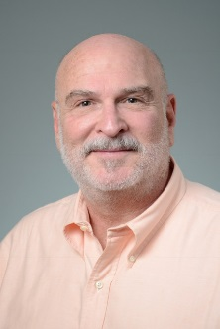**COURSE DESCRIPTION:** The lecture will analyze contract terms contained in dental provider agreements, in order to give attendees information to use in making informed decisions. The lecture will also discuss antitrust concerns, federal and state laws, and other current issues.

**Objectives:**

* Upon completion, participant will be able to better understand and analyze participating provider contract terms
* Upon completion, participant will understand antitrust concerns related to participating provider contracts.
* Upon completion, participant will understand legal concerns, including various federal and state laws, related to participating provider contracts.

**Title: Dentist Employment Agreements: A Guide to Key Legal Provisions - Sponsored by ADA  
Date: Saturday June 10, 2017 10:30am – 11:30am Location: 240/LA CIENEGA CEUs: 1**

**COURSE DESCRIPTION:** Course has been delivered on behalf of ADA at numerous dental schools (well over a dozen) and for various groups of dental students. The course focuses on educating attendees concerning legal provisions and issues arising from dentist employment agreements. Among the issues and provisions discussed are an employee-dentist’s duty, designation of independent contractor vs. employee, non-competition provisions, non-solicitation, malpractice insurance, dispute resolution, negotiation strategies, and the importance of attorney review of the employment agreement.

**Objectives:**

1. Upon completion, participants will be able to identify and understand the importance of key provisions that appear in dentist employment agreements, such as non-competition and independent contractor vs. employee.
2. Upon completion, participants will understand basics of negotiation of a proposed agreement.
3. Upon completion, participants will understand the importance of retaining an attorney to assist, as well as how to interview and select an attorney.

**~Howard Glazer – 108th Annual Session, The Dental Showcase– Speaker**

**Title: I have It…You Need It! (Must Have Products & Materials) Aka “What’s Hot & What’s Getting Hotter!”    
Date: Thursday June 8, 2017 9:00am – 12:00pm Location: 130/Cimarron-120/Dona Ana CEUs: 3**

**Date: Thursday June 8, 2017 2:00pm – 5:00pm Location: 130/Cimarron-120/Dona Ana CEUs: 3**

**COURSE DESCRIPTION:** This is a program about *real dentistry* for *real people* by a *real dentist*! Dr. Glazer will present a potpourri of the materials and techniques that he uses to make the day more productive, easier and fun! The entire dental team will benefit from learning together about the latest products and how they will benefit your patients. Dr. Glazer writes a monthly column by the same title for AGD Impact magazine, and reviews new products and materials on a regular basis for his column.

***Topics may include:***

* Curing lights..to light up your life (dental)
* Desensitiztion & Adhesives..a sticky subject made simple
* Composites for esthetic fillings not just white ones
* Impression materials..it’s true..first impressions are important
* Provisional materials.provisionals should look great
* Burs..so many and so little time
* Lasers..simple, easy and quick w/ great results
* Endodontic instruments..getting to the root of the matter
* Cements..that which holds the relationship together
* Tissue retraction and fluid control...essentials of clear fields
* Reducing Sensitivity with topical paste application & Fluoride varnishes
* Matrix bands for perfect, predictable contacts..contact perfect every time
* Whitening systems..that work
* Oral cancer prevention..dentists can save lives!
* Patient communication…high-tech and really cool!
* Going Digital..simple, easy and soon to be a must!
* Loupes, instruments, equipment potpourri

**Objectives:**

1. To learn the different types of materials in various product categories.
2. To learn what is faster, easier and better.
3. To be able to evaluate product claims and merit.
4. To understand the benefits of buffered anesthesia.
5. To understand the value of continual doctor/patient communication.
6. To understand how to utilize many of the newer bioactive materials.

**~ Joseph Griego– 108th Annual Session, The Dental Showcase– Speaker**

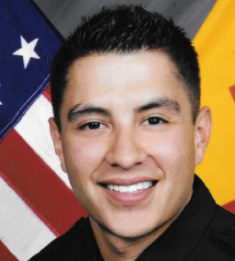**Title: BLS for Healthcare Providers  
Date: Friday June 9, 2017 2:00pm-5:00pm Location: 220/RUIDOSO-230/PECOS CEUs: 3  
Date: Saturday June 10, 2017 9:00am-12:30pm Location: 220/RUIDOSO-230/PECOS CEUs: 3**  **Course Description:** The BLS Healthcare Provider Course is designed to teach you the necessary skills to provide patients with high quality CPR.

**Objectives:**

* 2 Rescuer CPR and AED for adults, children, and infants
* Critical concepts of high quality CPR
* Chain of survival algorithm

**~Jane Grover – 108th Annual Session, The Dental Showcase– Speaker**

**Title: Action for Dental Health: Practice Success through Community Service  
Date: Thursday June 8, 2017 9:00am – 12:00pm Location: 235/Mesilla CEUs: 3**

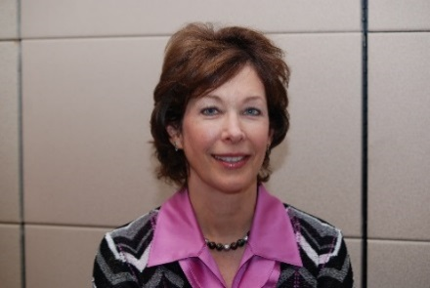**COURSE DESCRIPTION:**  Since 2013, the Action for Dental Health Campaign initiatives have shown where dentists are making a difference in several access to care strategies. Attendees of this course will learn how two of these strategies, ER Referral with the Community Dental Health Coordinator programs can not only expand oral health services to underserved populations, but can enhance their practice productivity and visibility. Community partnerships and stakeholder relationship development can serve to deepen professional satisfaction of the entire dental team with legislative impact as well.

**Objectives:**

1. Describe the value of dental case management and health literacy in patient care
2. Describe the Community Dental Health Coordinator program with advantages for both private practice and community programs
3. Understand the practical pathways for community engagement and oral health promotion
4. Describe the models of ER Referral that have shown success and how to develop one in your community
5. Understand the value of community surveillance and program metrics for grant possibilities

**~ Bernadette Jojola – 108th Annual Session, The Dental Showcase– Speaker**

**Title: Dental Radiography Safety  
Date: Friday June 9, 2017 9:00am – 12:00pm Location: Kiva Auditorium CEUs: 3**

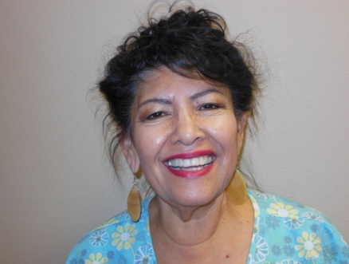**Course Description:** Topics covered include radiation protection, and safety of the patient, operator and staff. Discussion will include principles of x-ray production, use of conventional and digitized imaging. The course will compare exposure techniques and evaluate common errors and discuss features of a diagnostically acceptable radiograph.

**Objectives:**

* Explain the process of ionization.
* Discuss the methods of protecting the patient and operator from excess radiation.
* Review exposure and evaluation of radiographic images.
* Meet the required three hours for New Mexico certification.

**Title: OSHA Infection Control Update  
Date: Saturday June 10, 2017 9:00am – 12:00pm Location: 215/San Miguel-235/Mesilla CEUs: 3**

**Course Description**: The course will review the Summary of the Bloodborne Federal Standard. Discuss transmission of infectious diseases, including HIV& HCV. Discuss Post Exposure plans in the event of needlestick, sharps or splash exposures and Standard Precautions. Explanation of the revised Hazard Communication Standard under the new Globally Harmonized System will be covered.

**Objectives:**

* Describe the components of an OSHA exposure control plan.
* Explain the elements of the Bloodborne Federal Standard.
* Review the changes in the revised Hazard Communication Standard.

**~ Dan Klemmedsen – 108th Annual Session, The Dental Showcase– Speaker**

**Title: Opening Session: Forum: Issues for Dental Practice 2017  
Date: Thursday June 8, 2017 8:00am – 9:00am Location: Kiva Auditorium CEUs: 1**

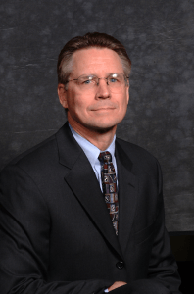**Course Description:** Join the conversation at a dental forum featuring a panel that includes: the president of the American Dental Association, Gary Roberts; 14th District Trustee, Dan Klemmedsen; NMDA President, Chris Morgan and others.  These leaders in dentistry will consider your questions or comments as the panel discusses current issues, the future of dental practice and the American Dental Association.  This will be a great start to the annual session for the entire dental team.

**~ Antonio Mancusso – 108th Annual Session, The Dental Showcase– Speaker**

**Title: Predictable and Efficient Provisionalization of the Anterior Aesthetic Case - Sponsored by Caulk/DENTSPLY  
Date: Friday June 9, 2017 9:00am-1200pm Location: 140/Aztec-110/Galisteo CEUs: 3**

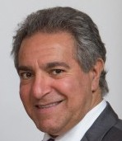**Course Description**: Many dentists find proviosionalization of anterior aesthetic cases to be stressful and long. Predictable and efficient temporization in less than 15 minutes is the norm when all the proper steps are taken, from case work-up to the preparation appointment. This program will take you step by step on the provisionalization protocol used to ensure that your cases become seamless. This technique will demonstrate how to create beautiful provisionals, that stay on! Numerous cases will be shown to demonstrate this technique, which you can readily incorporate into your practice Monday morning.

**Objectives:**

* Provisionalize your anterior aesthetic case in less than 15 minutes.
* Use of a sil-tech putty wash to minimize clean up.
* Working out aesthetics, phonetics, and incisal edge position in your provisionals.

**Title: Managing The Worn Dentition - Sponsored by Caulk/DENTSPLY  
Date: Friday June 9, 2017 2:00pm-5:00pm Location: 140/Aztec-110/Galisteo CEUs: 3**

**Course Description**: Today you have the greatest demographic cohort in history- the baby boomers, which are seeing the ravages of the aging process. They don’t like what they see and are ready and willing to do something about it. They often present with a worn dentition that can have often complex and multidisciplinary treatment plans. Often the treatment of choice involves comprehensive full mouth rehabilitation. Numerous cases demonstrating the management of the worn dentition will be shown.

**Objectives:**

* Records required for diagnosing, treatment planning and restoring the worn dentition.
* Using various diagnostic criteria to treatment plan the worn dentition.
* Multidisciplinary approach to case management of the worn dentition.

**~ Michael McDade – 108th Annual Session, The Dental Showcase– Speaker**

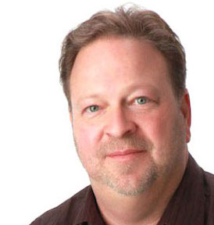**Title: Clon3D presents the Condor Intra-Oral Scanner  
Date: Thursday June 8, 2017 11:00am – 12:00Pm Location: Hall 4/ COL CEUs: 1**

**COURSE DESCRIPTION:** We will be demonstrating a better way to deliver a higher standard of patient care by utilizing the Condor Intra-Oral Scanner. Our goal is to demonstrate how the scanner can be used for diagnosis, presentation of findings for higher patient commitment and creating restorations that provide the best fit and accuracy since the beginning of time.  This leads to deeper trust and relationship with your patient, reduced time and costs per case and a deeper sense of fulfillment and confidence for the dentist, then lab and, most importantly, your patient.

**Title: Clon3D presents the Condor Intra-Oral Scanner  
Date: Thursday June 8, 2017 4:00pm – 5:00Pm Location: Hall 4/ COL CEUs: 1**

**COURSE DESCRIPTION:** We will be demonstrating a better way to deliver a higher standard of patient care by utilizing the Condor Intra-Oral Scanner. Our goal is to demonstrate how the scanner can be used for diagnosis, presentation of findings for higher patient commitment and creating restorations that provide the best fit and accuracy since the beginning of time.  This leads to deeper trust and relationship with your patient, reduced time and costs per case and a deeper sense of fulfillment and confidence for the dentist, then lab and, most importantly, your patient.

**Title: Clon3D presents the Condor Intra-Oral Scanner  
Date: Friday June 9, 2017 10:00am – 11:00am Location: Hall 4/ COL CEUs: 1**

**COURSE DESCRIPTION:** We will be demonstrating a better way to deliver a higher standard of patient care by utilizing the Condor Intra-Oral Scanner. Our goal is to demonstrate how the scanner can be used for diagnosis, presentation of findings for higher patient commitment and creating restorations that provide the best fit and accuracy since the beginning of time.  This leads to deeper trust and relationship with your patient, reduced time and costs per case and a deeper sense of fulfillment and confidence for the dentist, then lab and, most importantly, your patient.

**Title: Clon3D presents the Condor Intra-Oral Scanner  
Date: Friday June 9, 2017 3:00pm – 4:00Pm Location: Hall 4/ COL CEUs: 1**

**COURSE DESCRIPTION:** We will be demonstrating a better way to deliver a higher standard of patient care by utilizing the Condor Intra-Oral Scanner. Our goal is to demonstrate how the scanner can be used for diagnosis, presentation of findings for higher patient commitment and creating restorations that provide the best fit and accuracy since the beginning of time.  This leads to deeper trust and relationship with your patient, reduced time and costs per case and a deeper sense of fulfillment and confidence for the dentist, then lab and, most importantly, your patient.

**~Drew McDonald – 108th Annual Session, The Dental Showcase– Speaker**

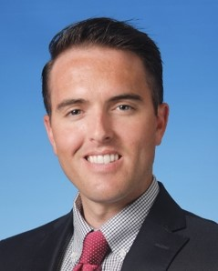**Title: Eat & Learn Breakfast: Going Old-School on Social Media – Using Social Media to Build Community, Differentiate Your Practice, and Generate More Word-of-Mouth Referrals  
Date: Thursday June 8, 2017 7:00m – 8:30am Location: 220/Ruidoso CEUs: 1**

**COURSE DESCRIPTION:** In today’s hyper-competitive dental market, it is important to differentiate your practice from others. Over the last decade, social media has become an important vehicle to attract patients. Sadly, many of us spend our hard-earned money trying to generate new patient leads just to have our social media pages look and feel just like every other dental practice. This lecture will demonstrate how we can use social media to tell your practice’s story, build community, and ultimately, attract more patients who actually “Like” your practice.

**Objectives:** Upon completion of this course, attendees should be able to:

1. Appreciate the forces that are driving social media to the forefront of practice growth
2. Understand how social media has traditionally been used to generate new patient leads
3. Recognize what prospective patients react to on social media
4. Form a strategy for utilizing social media to promote your practice within your community and separate you from being “just another dental practice”.

**Title: Orthodontics and Sports Dentistry: Mouth Guard Use and Effects on Jaw Muscles and the TMJ Complex**  
**Date: Thursday June 8, 2017 2:00pm – 3:00pm Location: 140/Aztec CEUs: 1  
  
COURSE DESCRIPTION:** This course will detail recent advances in sports mouth guards and how jaw muscles and the TMJ are affected and benefit by their design. It will also provide instruction on how to properly and efficiently fabricate custom mouth guards for your patients in office.

**Title: Perf Vibes: An Abbreviated Course in Accelerated Orthodontics  
Date: Thursday June 8, 2017 3:00pm – 4:00pm Location: 140/Aztec CEUs: 1**

**COURSE DESCRIPTION:** Recently, minimally-invasive procedures utilizing new technologies have been developed in effort to conveniently move teeth faster with less discomfort. This course will break down the newest techniques, evidence for their efficacy, and how we utilize them in orthodontic practice.  
  
**Title: Autism Spectrum Disorder (ASD) and Dentistry: Creating a Welcoming Environment for Dental Patients with ASD  
Date: Thursday June 8, 2017 4:00pm – 5:00pm Location: 140/Aztec CEUs: 1**

**COURSE DESCRIPTION:** The Center for Disease Control and Prevention (CDC) officially estimates that 1 in 68 American children born today are diagnosed with Autism Spectrum Disorder (ASD). As a dental practitioner and the father of a child with ASD, Dr. McDonald will offer information on the latest techniques for developing systems in your practice to create a welcoming environment and positive experience for patients with ASD.

**~Jane McGinley – 108th Annual Session, The Dental Showcase– Speaker**

**Title: Are You Ready to Advocate for Community Water Fluoridation?  
Date: Thursday June 8, 2017 2:00pm-5:00pm Location: 235/Mesilla CEUs: 3**

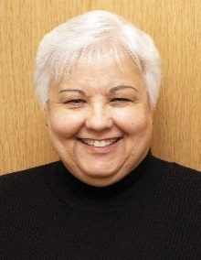**Course Description:**   In order to expand the number of people in the U.S. who receive the benefits of fluoridated water, it is not only necessary to initiate new fluoridation programs, but also maintain current programs. This update on the latest science will provide attendees with information to discuss fluoridation with patients and local decision makers. Participants will also learn about campaign strategies designed to aid in advocacy efforts.

**Objectives:**

1. Explain the scientific rationale behind the recommendation to fluoridate at 0.7 mg/L.
2. Provide scientific responses to fluoridation challenges
3. Identify successful campaign strategies and advocacy efforts to initiate and retain fluoridation programs.

**~ Kim Miller – 108th Annual Session, The Dental Showcase– Speaker**

**Title: Principle Based Periodontal Therapy and Treatment Planning  
Date: Thursday June 8, 2017 9:00am – 12:00pm Location: 115/Brazos CEUs: 3**

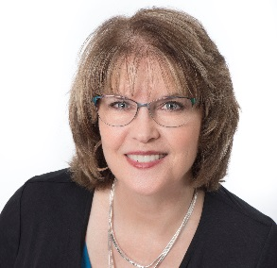**COURSE DESCRIPTION:** Are you frustrated with a cookie cutter approach to treating periodontal disease? Do you want to assist your patients in achieving disease remission? Then this is the course for you! You will be encouraged by the body of scientific evidence supporting your efforts to diagnose early and treat conservatively. You will discover diagnostic techniques and treatment options available to ‘help you’ help your patients understand and arrest their periodontal disease.

Utilizing a ‘Four-Pronged Approach’ encompasses treating from the top down, bottom up, inside out, and the outside in. This perspective will help your patients get their periodontal disease under control, reduce overall systemic inflammation and live healthier lives because of your efforts.

**Objectives:**

* Enhance your diagnostic protocols with clinical laboratory testing
* Refine your ability to handle patient objections
* Explore alternative treatment options for early intervention and increased profitability
* Learn advanced communication skills
* Individualize treatment plans using the ‘Four-Pronged Approach’

**Title: To Use or Not To Use: When Is The Question?  
Date: Thursday June 8, 2017 2:00pm – 5:00pm Location: 115/Brazos CEUs: 3**

**COURSE DESCRIPTION:** How am I supposed to fit that into my already packed hygiene appointment? If you are asking yourself this question, you are not alone. This program will assist the dental hygienist in quickly assessing individual patient needs and concerns while identifying opportunities for product and technology integration during continuing care and periodontal maintenance visits.  Kim brings her passion and over 30 years dental hygiene and coaching experience to this fast paced, energetic and engaging presentation.

Attendees will learn verbal and non-verbal communication skills that set you apart as a clinician including proxemics (how we use our body), positioning (patient and clinician), and words to use (or not use) to enhance communication allowing for patient education in less time. Kim shares tips and techniques for improving patient care by integrating products into everyday clinical practice, as well as technology which enhances periodontal and restorative diagnosis.

**Objectives:**

* Understand new as well as tried and true products and technology available to enhance Dental Hygiene services and patient care.
* Learn about proxemics and why you should care.
* Recognize the “f” word (you’ll be surprised what it is!) and why it turns patients off.
* When and how to incorporate products and technology into daily treatment.
* The musts of patient education and advanced communication

**~ Chris Morgan – 108th Annual Session, The Dental Showcase– Speaker**

**Title: Opening Session: Forum: Issues for Dental Practice 2017  
Date: Thursday June 8, 2017 8:00am – 9:00am Location: Kiva Auditorium CEUs: 1**

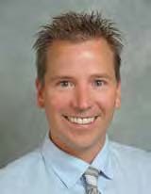**Course Description:** Join the conversation at a dental forum featuring a panel that includes: the president of the American Dental Association, Gary Roberts; 14th District Trustee, Dan Klemmedsen; NMDA President, Chris Morgan and others.  These leaders in dentistry will consider your questions or comments as the panel discusses current issues, the future of dental practice and the American Dental Association.  This will be a great start to the annual session for the entire dental team.

**~ Michael Moxey – 108th Annual Session, The Dental Showcase– Speaker**

**Title: The Price is Right!  
Date: Thursday June 8, 2017 1:00pm – 2:00pm Location: Hall 4 CEUs: 1**

**COURSE DESCRIPTION: “**The Dental Price is Right”: Join us for a live game show extravaganza featuring the latest dental products and the opportunity to win exciting prizes.  Everyone is welcome to “come on down” to the Center of Learning stage on Thursday and Friday afternoon at 1pm to participate in the games and giveaways. 

**Title: The Price is Right!  
Date: Friday June 9, 2017 1:00pm – 2:00pm Location: Hall 4 CEUs: 1**

**COURSE DESCRIPTION: “**The Dental Price is Right”: Join us for a live game show extravaganza featuring the latest dental products and the opportunity to win exciting prizes.  Everyone is welcome to “come on down” to the Center of Learning stage on Thursday and Friday afternoon at 1pm to participate in the games and giveaways. 

**~ Linda Nichols – 108th Annual Session, The Dental Showcase– Speaker**

**Title: Ethics For One, One For Ethics -** Albert L. Mulliken Series  
**Date: Thursday June 8, 2017 2:00pm – 5:00pm Location: 230/Pecos CEUs: 3**

**COURSE DESCRIPTION:** Know the origin of ethics and the role that ethics play in society

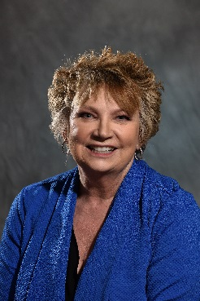  
**Objectives:** Upon the completion of this course, the participant will be able to:

1. Know the origin of ethics and the role that ethics play in society
2. Will possess the tools to access and report on central issues in clinical ethics.
3. Have participated in trial situation where the application of dental ethics as explored and reported to the audience group

**~Jonathan Parker – 108th Annual Session, The Dental Showcase– Speaker**

**Title: Treating Snoring and Obstructive Sleep Apnea (OSA): Grow Your Practice and Change People’s Lives – Part 1  
Date: Friday June 9, 2017 9:00am-12:00pm Location: 130/Cimarron-120/Dona Ana CEUs: 3**

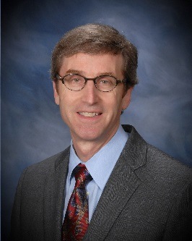**Course Description:** Over 50% of the patient’s in your practice have a snoring problem and it is now estimated that 17% of adults in the United States have obstructive sleep apnea (OSA). Snoring and OSA can have a significant effect on marriages, relationships, and a patient’s overall health. This entertaining and informative presentation will provide you with a clear understanding of all aspects of snoring and OSA and a step-by-step approach to identifying, evaluating and coordinating treatment for your patients. Come to this course and learn how you can change the lives of your patients and revitalize your career in dentistry by incorporating this discipline into your practice.

**Objectives:**

* Know how snoring and OSA occur.
* Understand evaluation, diagnostic testing and the medical treatment options.
* Understand how oral appliances work.

**Title: Treating Snoring and Obstructive Sleep Apnea (OSA): Grow Your Practice and Change People’s Lives – Part 2  
Date: Friday June 9, 2017 2:00pm-5:00pm Location: 130/Cimarron-120/Dona Ana CEUs: 3**

**Course Description:** This presentation will provide you with an exceptional guide to treating snoring and OSA with oral appliance therapy. You will be given successful protocols that will help you successfully treat your patients. You will learn the features and characteristics of 8 different oral appliances as well as the benefits and potential side effects of these devices. This program will give you the practical clinical information you need to immediately incorporate dental sleep medicine into your practice. The practice of dental sleep medicine can change patient’s lives and re-energize your professional life. (This afternoon program is a continuation of the morning Session-Part 1)

**Objectives:**

* Understand the step-by-step protocols for use of oral appliances.
* Understand the features of many oral appliances currently in use.
* Understand the possible complications and side effects of oral appliance therapy

**~Howard Pollick – 108th Annual Session, The Dental Showcase– Speaker**

**Title: Are You Ready to Advocate for Community Water Fluoridation?  
Date: Thursday June 8, 2017 2:00pm-5:00pm Location: 235/Mesilla CEUs: 3**

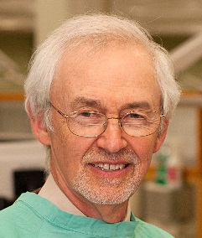**Course Description:**   In order to expand the number of people in the U.S. who receive the benefits of fluoridated water, it is not only necessary to initiate new fluoridation programs, but also maintain current programs. This update on the latest science will provide attendees with information to discuss fluoridation with patients and local decision makers. Participants will also learn about campaign strategies designed to aid in advocacy efforts.

**Objectives:**

1. Explain the scientific rationale behind the recommendation to fluoridate at 0.7 mg/L.
2. Provide scientific responses to fluoridation challenges
3. Identify successful campaign strategies and advocacy efforts to initiate and retain fluoridation programs.

**~ Dan Poticny – 108th Annual Session, The Dental Showcase– Speaker**

**Title: 21st Century Solutions: Materials, Process, Application and Placement - Sponsored by 3MESPE  
Date: Friday June 68, 2017 9:00am – 12:00pm Location: 240/La Cienega CEUs: 3**

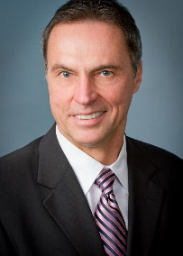**Course Description:**  Discuss 21st Century Solutions:  Materials, Process, Application and Placement

**Objectives:**

1. Understand glass, crystalline, and hybrid ceramics
2. Understand applications, and rationale for their use
3. Understand digital process for both lab and chairside construction
4. Understand cementation and bonding for these modern materials

**~ Steve Rasner – 108th Annual Session, The Dental Showcase– Speaker**

**Title: The Thriving Fee for Service Practice in 2017  
Date: Thursday June 8, 2017 9:00am – 12:00pm Location: 220/Ruidoso CEUs: 3  
Date: Thursday June 8, 2017 2:00pm – 5:00pm Location: 220/Ruidoso CEUs: 3**

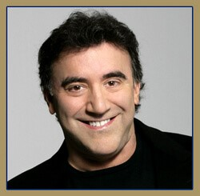**Course Description:** This powerful and inspiring presentation was designed to provide a real world recipe for breaking away from third-party carriers and regaining your independence. Drawing from the experience gained in 30 consecutive years of increased growth and profitability, Dr. Rasner explains the protocols and foundations that can elevate any dental practice to extraordinary levels of success. Protocols that will motivate patients to go out of network for your services, guaranteed. Practice management strategies that skyrocket case acceptance, increase cash Blow, and decrease the bumps in your day. Use it on Monday production-enhancing clinical gems that range from enhancing your soft tissue esthetics to dramatically improving your anesthetic technique. Leadership principles that have kept his staff of 21 together for an average of 17 years, without going broke! The psychology of winning: the mental toughness we all need to bounce back from that bad week. Lastly, where balance Bits into the dynamic of success. How the super achiever can give back to the world and not miss out on the most important parts of the journey: family, and a full life.

**~ Gary Roberts – 108th Annual Session, The Dental Showcase– Speaker**

**Title: Opening Session: Forum: Issues for Dental Practice 2017  
Date: Thursday June 8, 2017 8:00am – 9:00am Location: Kiva Auditorium CEUs: 1**

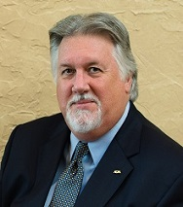**Course Description:** Join the conversation at a dental forum featuring a panel that includes: the president of the American Dental Association, Gary Roberts; 14th District Trustee, Dan Klemmedsen; NMDA President, Chris Morgan and others.  These leaders in dentistry will consider your questions or comments as the panel discusses current issues, the future of dental practice and the American Dental Association.  This will be a great start to the annual session for the entire dental team.

**~ Thomas Schripsema – 108th Annual Session, The Dental Showcase– Speaker**

**Title: Opening Session: Forum: Issues for Dental Practice 2017  
Date: Thursday June 8, 2017 8:00am – 9:00am Location: Kiva Auditorium CEUs: 1**

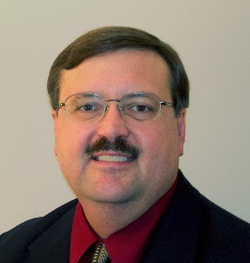**Course Description:** Join the conversation at a dental forum featuring a panel that includes: the president of the American Dental Association, Gary Roberts; 14th District Trustee, Dan Klemmedsen; NMDA President, Chris Morgan and others.  These leaders in dentistry will consider your questions or comments as the panel discusses current issues, the future of dental practice and the American Dental Association.  This will be a great start to the annual session for the entire dental team.

**~ Roy Shelburne – 108th Annual Session, The Dental Showcase– Speaker**

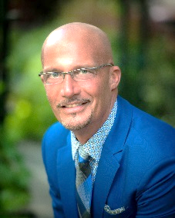**Title: Clinical Records Prevent Criminal Records: "Do Dentistry, Not Time"  
Date: Friday June 9, 2017 9:00am-12:00pm Location: 215/ San Miguel CEUs: 3**  
  
**Course Description:** There are ways to protect and defend a dental practice and to prevent what happened to him from happening to you.  You can protect your practice in the event of a Board complaint, insurance audit, malpractice claim, or criminal complaint.

Dr. Shelburne found that his records and systems were faulty.  He learned that it is critical and possible to implement protocols and form a defensive systemic approach to record keeping.  Know that if it's not in your clinical record, you didn't see it, you didn't say it, you didn't do it, it didn't need to be done, and it doesn't exist.... from the legal perspective. To be prepared for any challenge the whole dental team must be careful, concise, complete, and diligent, not just the doctor.  Learning and implementing this no non-sense team approach to record keeping could mean the difference between success and failure in the event of an action or challenge to your practice.

**Objectives:**

* To understand that what you don’t know can hurt you and that ignorance is no excuse.
* To learn to assimilate and maintain records that can both protect and defend.
* Understand the necessity of due diligence and how to conduct records review and internal audits to accuracy and insure accuracy and excellence.

**Title: Team Luncheon: Stop the Insanity, By Doing Things Differently**

**Date: Friday June 9, 2017 11:45pm-1:00pm Location: Hall 4 CEUs: 1**

**Course Description:** Risk is everywhere.  Having served as Chairman of the Board of a local not for profit hospital, I observed first-hand the benefits of the quality improvement principles as they applied to medicine and the hospital environment.  Quality improvement principles work very efficiently and effectively to improve the systems of operation and reduce risk when adopted in the dental environment as well.  Application of these principals in dental practices has ultimately resulted in more streamlined systems of operation, increased job satisfaction, improved treatment outcomes and elevated overall patient satisfaction.  The purpose of this presentation is to share the principals of quality improvement and to empower the dental team to adopt and implement these principles making what we do easier and better.

**Objectives:**

* To understand the principles of quality improvement.
* To appreciate that the implementation of quality improvement systems will improve patient outcomes, increase revenue, and reduce stress in the dental environment.
* To be able to implement the principals of quality improvement into the everyday practice of dentistry.

**Title: Maneuvering the Coding Minefield**

**Date: Friday June 9, 2017 2:00pm-5:00pm Location: 215/ San Miguel CEUs: 3**

**Course Description:** When the practice is paid rapidly and appropriately, things are good; however, when there are delays, denials, and requests for additional information, thing are not quite so good.  Mistakes can be devastating to the practice.

During the investigation as well as in the preparation for and during my trial it became apparent that my billing and coding systems were faulty.  I now educate others so that they can bill and code appropriately. My message is; it is possible to implement systems that can form a proactive defensive systemic approach that will result in maximum legitimate reimbursement.  To be prepared for this challenge the team must be careful, concise, complete, and diligent.  Learning and implementing my approach will result in higher reimbursement while reducing the risk associated with the coding piece of the practice.  If the deficiencies in your systems are ignored both doctor and staff are at risk.

**Objectives:**

* To recognize the dangers in coding improperly and benefits of coding properly.
* To know the most commonly misused codes and how to avoid the “usual” errors.
* To be able to develop systems that get your services paid and prevent coding errors.
* “Risky business, where’s the danger and how to prepare:”

**~ Kyle Stanley – 108th Annual Session, The Dental Showcase– Speaker**

**Title: The Biggest Problems in Implant Dentistry and How to Avoid Them  
Date: Thursday June 8, 2017 9:00am – 12:00pm Location: 215/San miguel CEUs: 3  
Date: Thursday June 8, 2017 2:00pm – 5:00pm Location: 215/San miguel CEUs: 3**

**Course Description:** This presentation will present key points formulated into a systematic step-by-step approach to resolve significant esthetic problems restoring the esthetic zone up to full-mouth rehabilitations. Dr. Stanley will show you the biggest problems in implant dentistry and how to avoid them. Topics include: Digital Smile Design, upper lip planning and augmentation for maximum esthetics, the team approach to guided implant surgery planning with NobelClinician, abutment modifications to maximize soft tissue around implants, how and when to use pink porcelain.  Dr. Stanley will also introduce a state of the art approach to restore teeth with actual enamel and dentin!

**Objectives:** Upon completion of this presentation, attendees should be able to:

* Interdisciplinary Esthetic treatment: How to design a smile and plan cases in a digital format.
* Restore implants in the esthetic zone: Select ceramic materials, utilize techniques for optimum esthetic results.
* Fine Technique Details: Implant abutment design and modification; Restoring teeth with natural enamel and dentin!

**~Tim Twigg – 108th Annual Session, The Dental Showcase– Speaker**

**Title: The Employment Compliance**

**Date: Thursday June 8, 2017 9:00am – 12:00pm Location: 230/Pecos CEUs: 3**

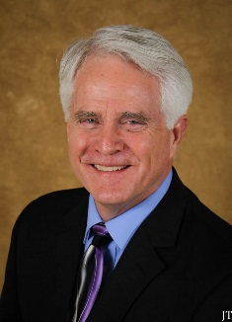**COURSE DESCRIPTION:** Since human resource management and compliance with the variety of state and federal labor regulations are not taught in the typical dental school curriculum, doctors often find themselves in court regarding employment issues. Such lawsuits can be emotionally draining and financially devastating. Dealing wisely and effectively with complex employment issues can be particularly challenging and personnel issues are a major source of stress for most practitioners. This can come in various forms such as: employee pay, benefits (vacation, sick, medical, retirement, etc.), leave of absence, pregnancy, hiring, and termination, just to name a few.  
  
Geared for the dentist/owner, this presentation delves deeply into how to easily apply proven, professional personnel management techniques to some of the many common personnel problems to help take the risk out of being an employer and insure employment law compliance. Each participant will be provided with a presentation handout along with supporting resource material. Doctor, Spouse, Bona Fide Office Manager only.

**Objectives:** During this presentation participants will learn how to:

* Determine their degree of potential exposure and liability.
* Minimize exposure to potentially costly lawsuits and complaints.
* Insure compliance with State and Federal employment regulations.
* Prevent misunderstandings--create a positive and productive work
* environment.
* Define rights and responsibilities of employer and employees.
* Improve morale and job performance.
* Hire the right people.
* Reduce costly staff turnover.

**Title: Building That Illusive Winning Team**

**Date: Thursday June 8, 2017 2:00pm – 5:00pm Location: 110/Galisteo**  **CEUs: 3**

**COURSE DESCRIPTION:** Nothing contributes to a practice’s consistent, long-term success like a truly effective and cohesive team. Building a winning team is not an illusive, unachievable task. In fact, it is very attainable when you possess the basics skills of recruitment, selection, and retention, coupled with effective communication and team management.

The alternative, high employee turnover, is a killer—patient care suffers, stress levels are high, and the bottom line is significantly impacted. Building a winning is not just about finding people with skill, but instead knowing how to find and identify people with the right attitude.  
  
Geared for dentist and staff, this presentation teaches participants the principles behind team development and team building, as well as the techniques for maintaining a winning team. Participants will come away excited and motivated, with greater self-initiative and desire to succeed.

**Objectives:** During this presentation participants will learn:

* 12 key elements for building a winning team.
* Foundational components necessary for successful hiring practices.
* Skills for more effective recruitment, i.e. finding the right team players.
* Selection tools that increase the odds of long term hiring success.
* Hazards associated with background checks.
* Retention fundamentals that contribute to team stability, better job performance, and reduced turnover.
* Performance evaluations and feedback techniques to insure quality communication and great team morale.
* Where team meetings fit into the success paradigm and the “how-when-where-and-who” guidelines for effective team meetings.

**~ Joe Valles – 108th Annual Session, The Dental Showcase– Speaker**

**Title: Opening Session: Forum: Issues for Dental Practice 2017  
Date: Thursday June 8, 2017 8:00am – 9:00am Location: Kiva Auditorium CEUs: 1**

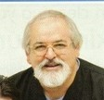**Course Description:** Join the conversation at a dental forum featuring a panel that includes: the president of the American Dental Association, Gary Roberts; 14th District Trustee, Dan Klemmedsen; NMDA President, Chris Morgan and others.  These leaders in dentistry will consider your questions or comments as the panel discusses current issues, the future of dental practice and the American Dental Association.  This will be a great start to the annual session for the entire dental team.

**~Stephen Wagner – 108th Annual Session, The Dental Showcase– Speaker**

**Title: Now you can do it! High-quality dentures in three brief appointments!**

**Date: Thursday June 8, 2017 2:00pm – 5:00pm Location: 210/Tijeras CEUs: 3**

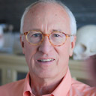**COURSE DESCRIPTION:** Dr. Wagner is eager to demonstrate his new technique that allows the clinician to fabricate contemporary, first-quality complete dentures in three, thirty minute appointments. This hands-on program stresses a practical and common sense approach to efficiently care for the edentulous patient.

**OBJECTIVES:** Following completion of the program, the participant should have the knowledge to:

1. Understand the skills required to diagnose and treatment plan the edentulous patient.
2. Learn accelerated impression and record making techniques designed to be performed in a highly efficient, three appointment workflow.
3. Organize and implement a simplified but high-quality denture service in a contemporary dental practice.

**~ Joel Waldman – 108th Annual Session, The Dental Showcase– Speaker  
Title: Preserving Retirement Savings With Long-Term Care Coverage**

**Date: Thursday June 8, 2017 2:00pm – 3:00pm Location: Exhibit Hall 4/COL CEUs: 1  
Date: Friday June 9, 2017 2:00pm – 3:00pm Location: Exhibit Hall 4/COL CEUs: 1**

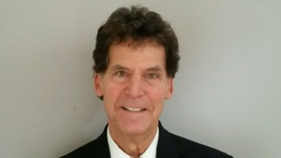

**COURSE DESCRIPTION:** In 2000, almost 10 million people needed some form of long-term care in the United States. Of this population, 3.6 million (37%) were under age 65 and 6 million (63%) were over age 65 (Roger & Komisar, 2003). Additionally, for individuals age 65 and older, the chances of having a chronic illness, injury or cognitive issue are approximately 70%. The primary means to pay for the necessary care will be one’s assets or a long-term care policy.

Long-term care coverage can protect the assets that a person has spent a lifetime accumulating. During the presentation the speaker will utilize his own personal experience with developing a condition that necessitated a premature exit from the practice of dentistry and its financial ramifications, as a way to highlight the necessity of planning for the unexpected.

**OBJECTIVES:** After this presentation, the attendee will be able to:

1. define long-term care insurance and name 3 common misconceptions;
2. describe how long-term care can protect retirement savings and the tax advantages for dentists; and
3. explain what hybrids are and why they are becoming a more relevant piece of the asset protection puzzle.

**~Byron Wall – 108th Annual Session, The Dental Showcase– Speaker**

**Title: Practical Occlusion in Everyday Practice  
Date: Friday June 9, 2017 9:00am – 1200pm Location: 115/Brazos CEUs: 3  
Date: Friday June 9, 2017 2:00pm – 5:00pm Location: 115/Brazos CEUs: 3**

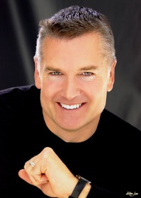**COURSE DESCRIPTION:** Bites are affected by virtually every procedure we dentists perform.  Most of us find that the principles we were taught in dental school simply do not help us in many cases.  This presentation is aimed at simplifying getting patient's bites correct in routine dental procedures, recognizing patients that already have underlying TMJ issues and jaw mis-alignments and what causes them.

Most people and many dentists do not realize that most headaches and many ear neck and joint symptoms are caused by a bad bite.  The purpose of this class is to more easily identify patients that have occlusal disharmony, jaw misalignments or TMD before starting restorative dentistry and how to make that treatment more successful.  This will be a lively and entertaining course!

**Objectives:** Attendees will advance their skills and ability to:

* Recognize signs and symptoms of TMD and Occlusal disharmony
* Gain comfort in treating TMD and occlusion
* Debunk a number of myths that pervade and unnecessarily complicate the subject of occlusion
* Simplify the approach to getting the bite right.
* Recognize when it is best to restore a patient in their current bite and when the bite should be addressed first
* Gain confidence in the verbal skills to use with a patient who has TMD--Patients are not interested in treatment until they understand and "own" the problem

**~Ron Wang – 108th Annual Session, The Dental Showcase– Speaker**

**Title: Extraction Socket Management - Lecture - Sponsored by Geistlich   
Date: Thursday June 8, 2017 8:3:00am – 12:30pm Location: Suite E/F CEUs: 4**

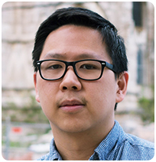**COURSE DESCRIPTION**: Management of extraction sites is key to successful implant and restorative procedures. Ridge preservation is a clinical procedure that aims at preventing bone loss following tooth extraction. Following tooth extraction, the alveolar process undergoes a marked alteration that is more pronounced in the buccal bone. Socket graft with bone substitutes can compensate for such bone loss. This course discusses treatment planning, tooth removal, site preparation, procedures, complications and techniques including for socket grafting, bone augmentation and ridge preservation.

**Objectives:**

* Understand the biology of the incorporation of the socket graft.
* Learn the principles of socket grafting/ridge augmentation surgery.
* Understand the importance of biomaterial selection and healing times effecting the long-term bone stability.

**Follow by Hands on Workshop**

**COURSE DESCRIPTION:**  Hands-on demonstration of effective, simple, predictable and cost effective socket grafting techniques.  
**Objectives:** Upon completion of this workshop, participants should be able to:

1. describe the dimensional alterations that take place in the alveolar process following tooth extraction;
2. discuss the scientific evidence concerning the benefit of ridge preservation following tooth extraction;
3. describe the ridge preservation surgical technique.

**~Andrea Wiseman – 108th Annual Session, The Dental Showcase– Speaker**

**Title: The Power of Prevention  
Date: Thursday June 8, 2017 11:00am – 200pm Location: 110/Galisteo CEUs: 3**

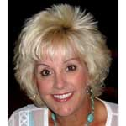**COURSE DESCRIPTION:** This dynamic presentation will provide a thorough review of caries risk assessment (CAMBRA), and how it can be implemented into a practice. Patient communications and insurance codes when treating moderate to high risk caries patients will be presented. Fluoride medications and dispensing protocols will be discussed.

**Objectives:**

* Discover the benefits of a Caries Risk Assessment program (CAMBRA)
* How to implement a caries risk assessment program into your practice
* Review Periodontal Risk Assessment and Protocols
* Understand fluoride medications and how to use them consistently
* Learn treatment options, protocols, dialog, insurance codes for sensitivity, caries, gingivitis and periodontal disease
* Learn how to motivate, educate, and medicate your patients differently
* White Spot Reversal Protocol